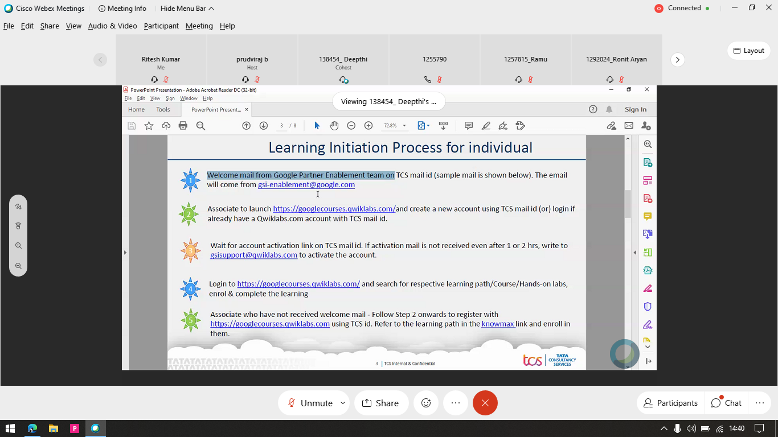

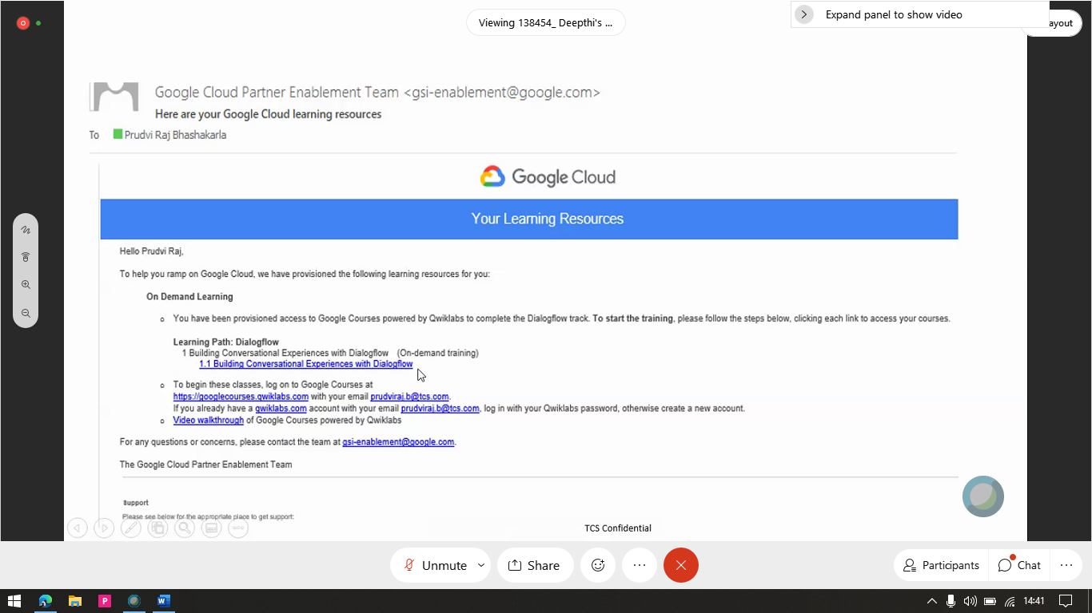

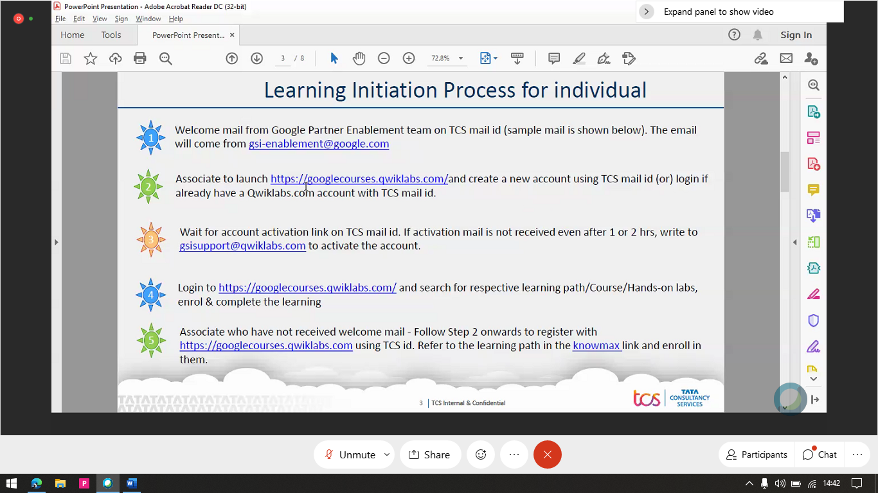

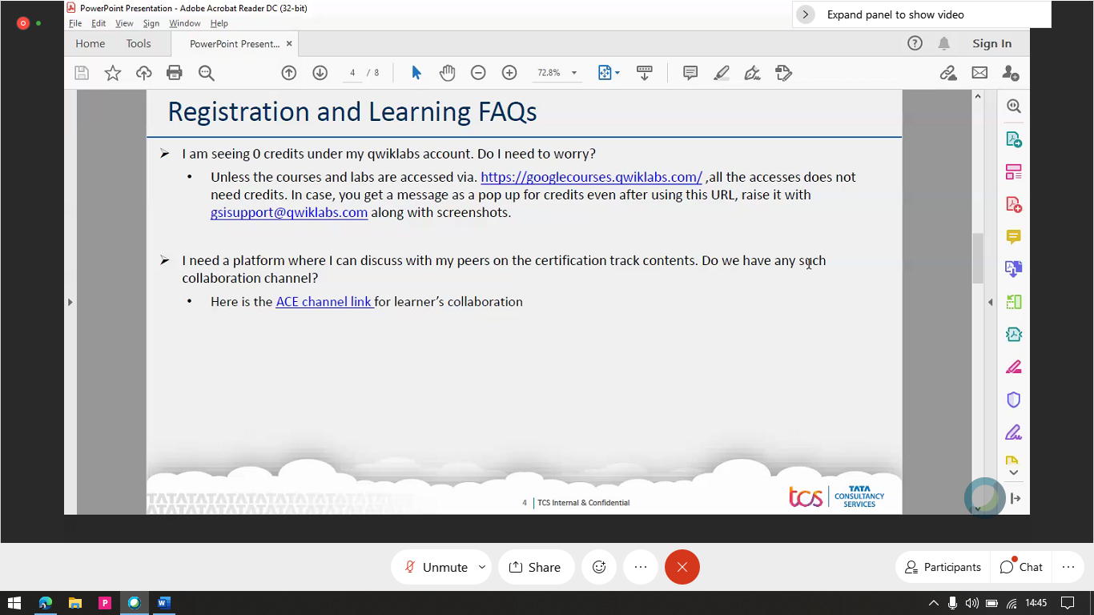

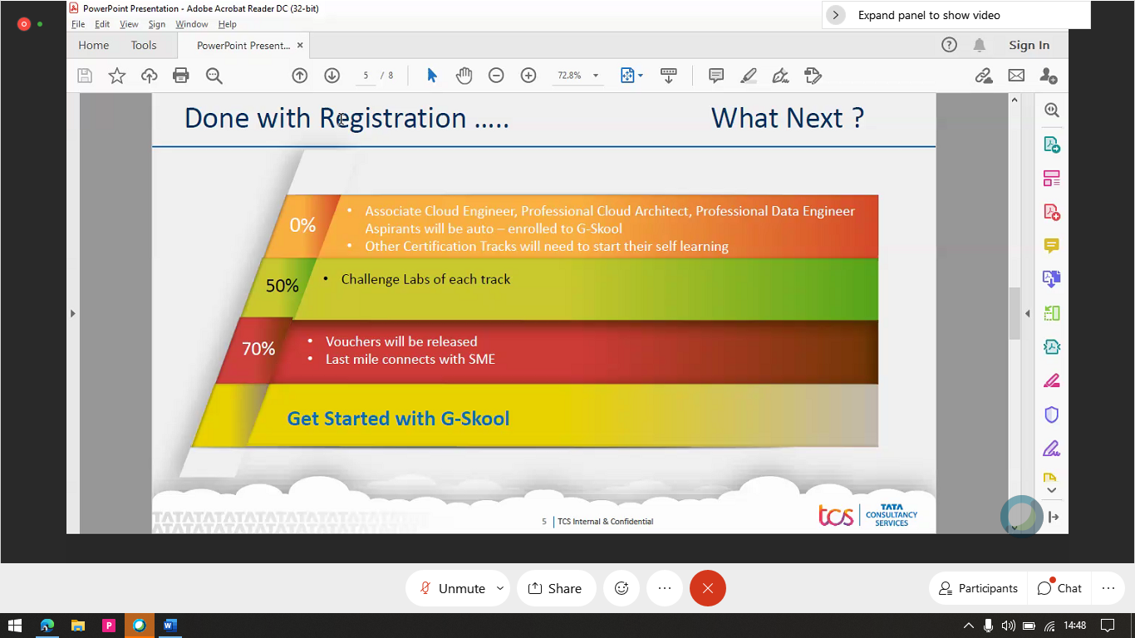

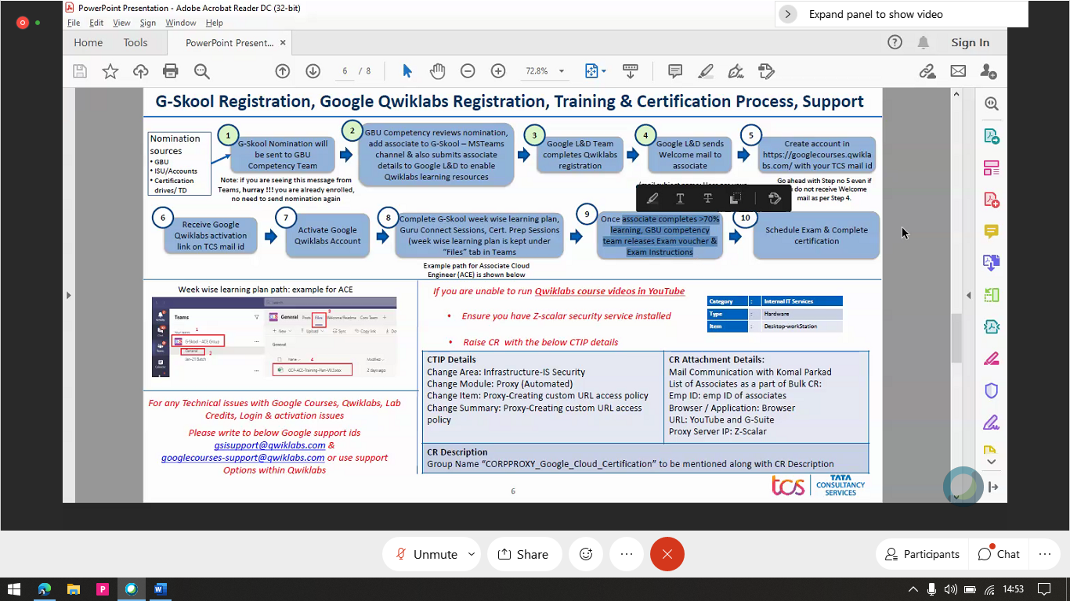

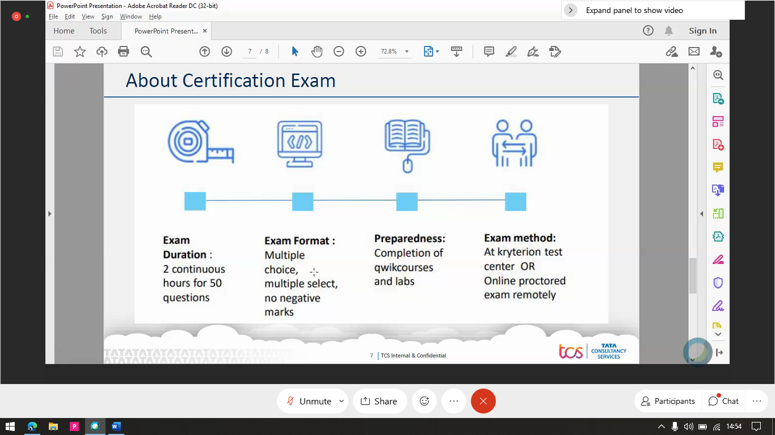

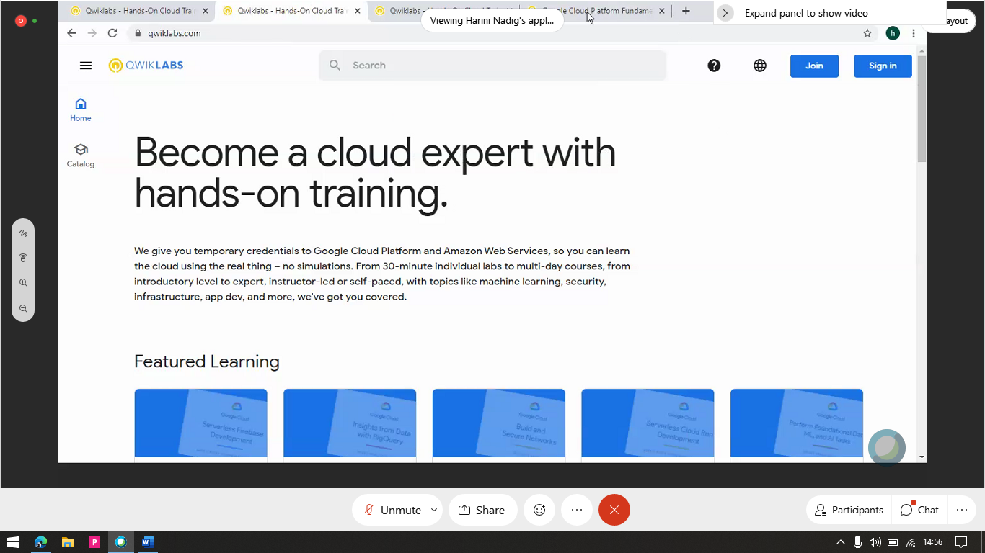

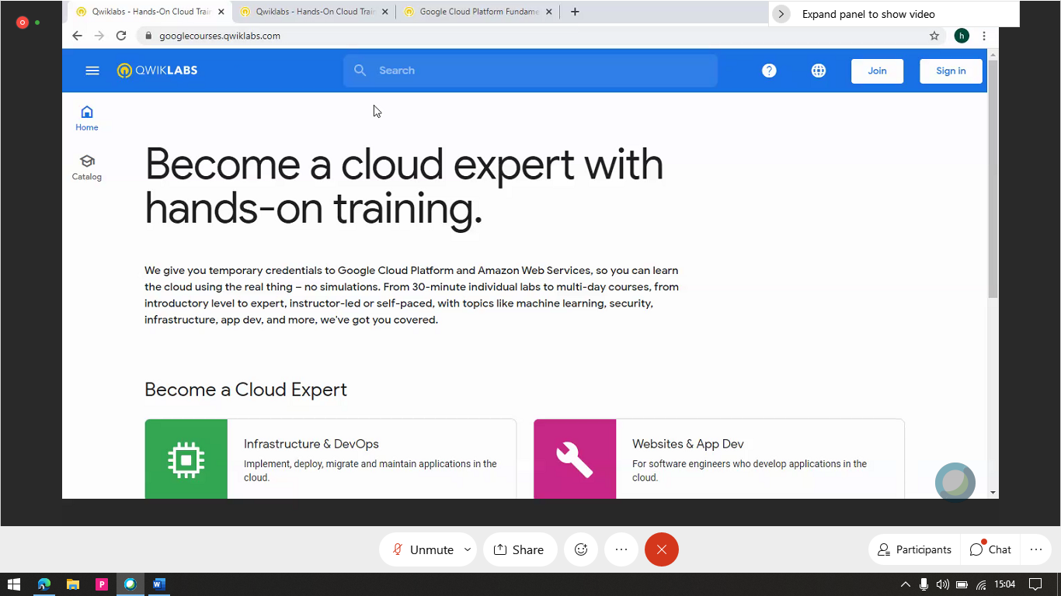

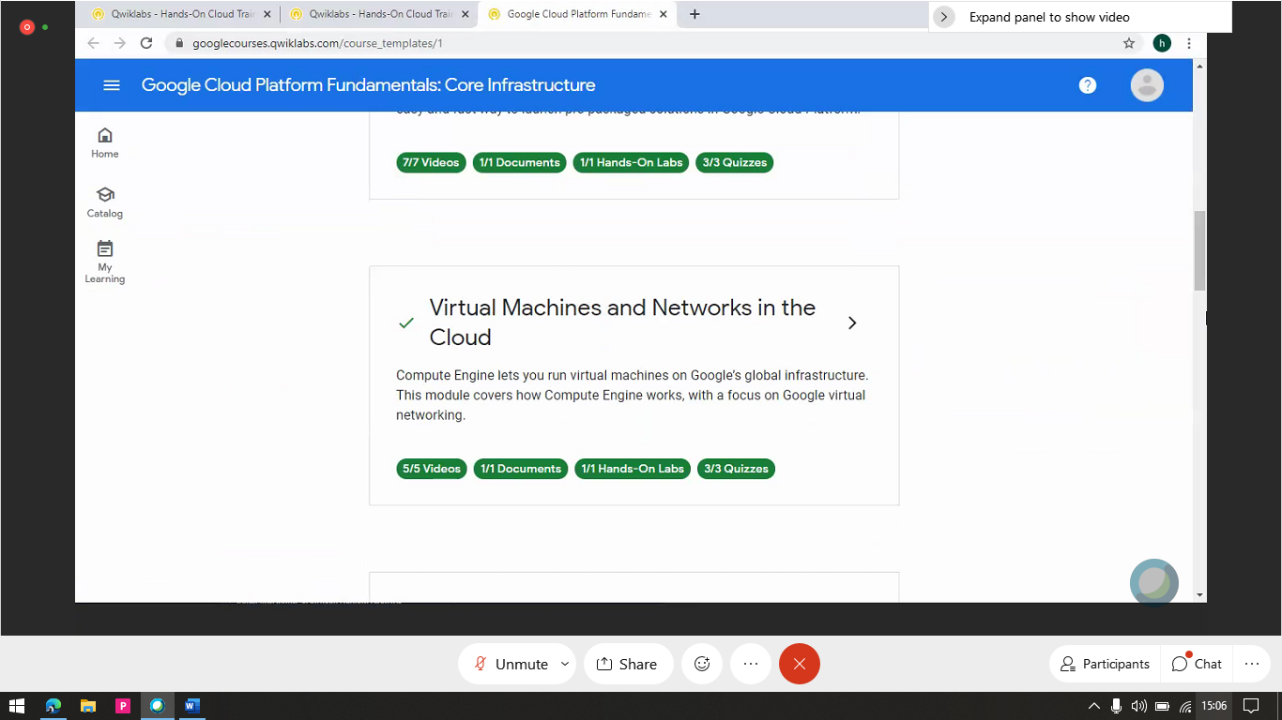

from Ramkumar Kandasamy to everyone: 2:34 PM

Hi

from Seema to everyone: 2:34 PM

Hello

from 696557_Sreelakshmi Sakivela to everyone: 2:37 PM

Hi

from 696557_Sreelakshmi Sakivela to everyone: 2:38 PM

Will you share recording after the session?

from Pinaki Aich to everyone: 2:45 PM

Hi Deepthi ..One quick question we will automatically get the welcome email ..

from sasitharan to everyone: 2:45 PM

Hi deepthi, can you share the knowmax link

from 327332_Kotesh to everyone: 2:49 PM

Will there be similar track run for PCA?

from vndpgodwin to everyone: 2:51 PM

how to we know if we completed 50% and 70% , how do you calculate it ?

from prudviraj b to everyone: 2:51 PM

yes, we will have similar sessions planned for PCA

from Saroj Gharat to everyone: 2:52 PM

Will this presenation be shared ?

from Laxmikanth to everyone: 2:55 PM

Can one associate can be enrolled to multiple courses(certifications)

from prudviraj b to everyone: 2:55 PM

only one certification can be enrolled at a time

from Laxmikanth to everyone: 2:57 PM

ok Thank you

from prudviraj b to everyone: 2:57 PM

post completion of one certification, other certification can be enabled

from 138454_ Deepthi to everyone: 3:07 PM

https://knowmax3.ultimatix.net/corpsites/bts-hsdu/GBU/SitePages/GSkool.aspx

from 138454_ Deepthi to everyone: 3:07 PM

@327332_Kotesh - yes we will have PCA starting next week

from 138454_ Deepthi to everyone: 3:08 PM

@vndpgodwin - we have uploaded the syllabus sheet in the knowmax link. this will help you with the calculation

from Pinaki Aich to everyone: 3:10 PM

Please ping the quicklab support mail id ..

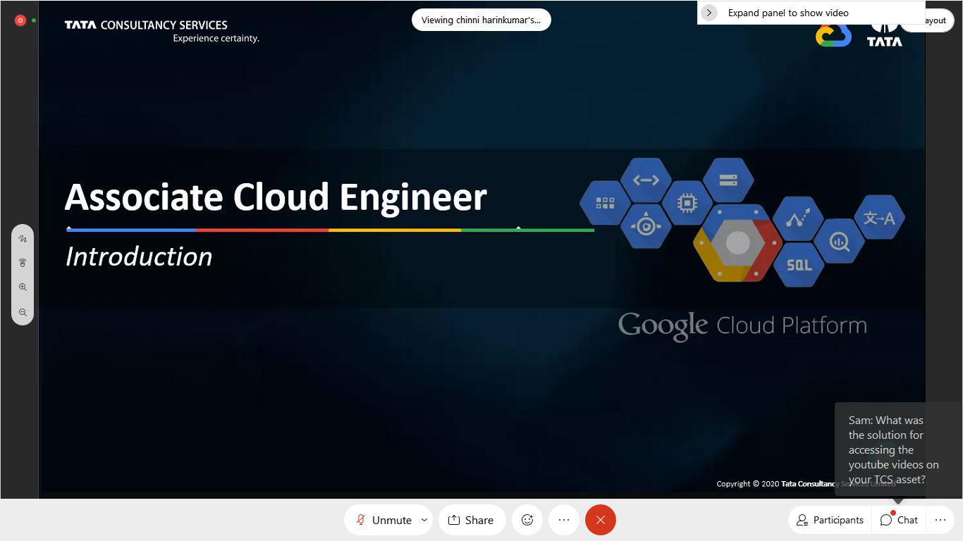

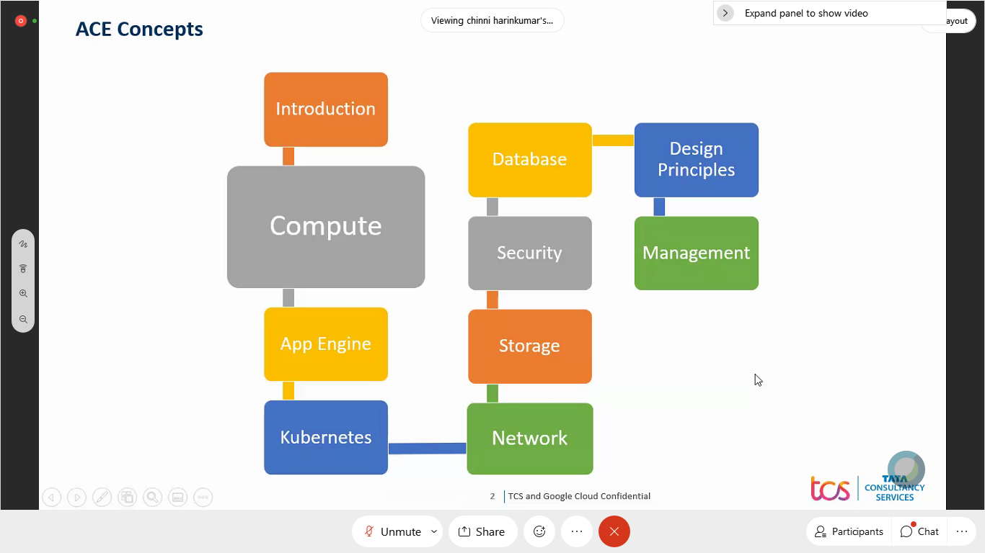

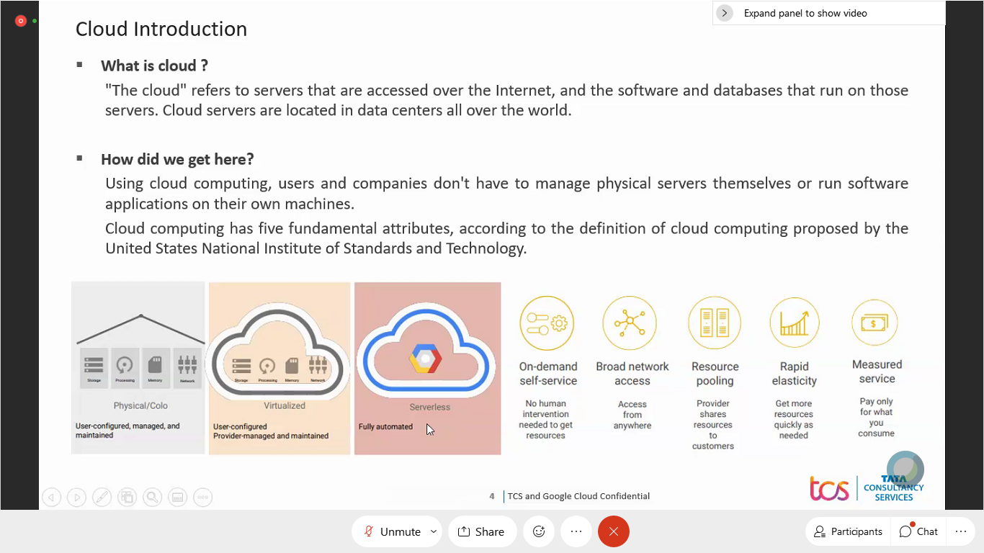

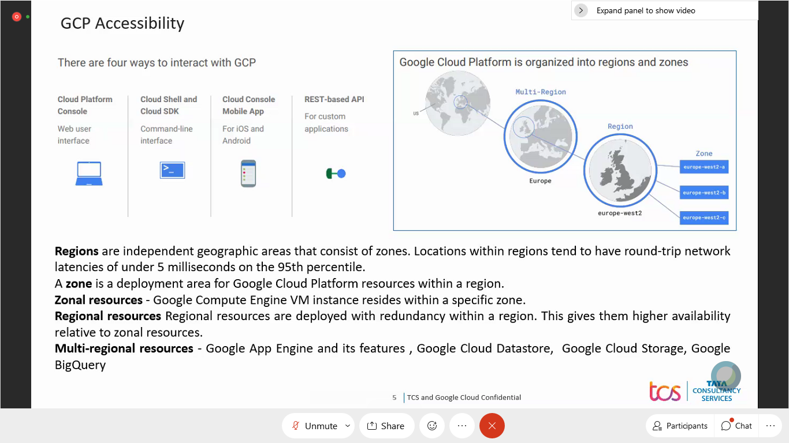

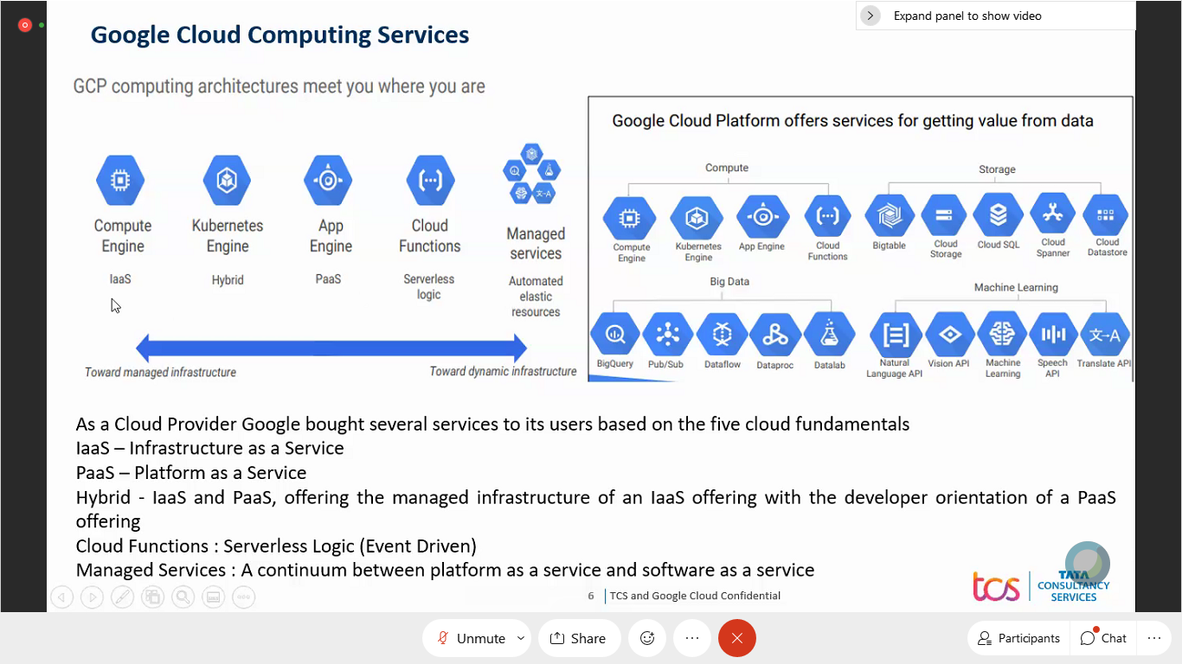

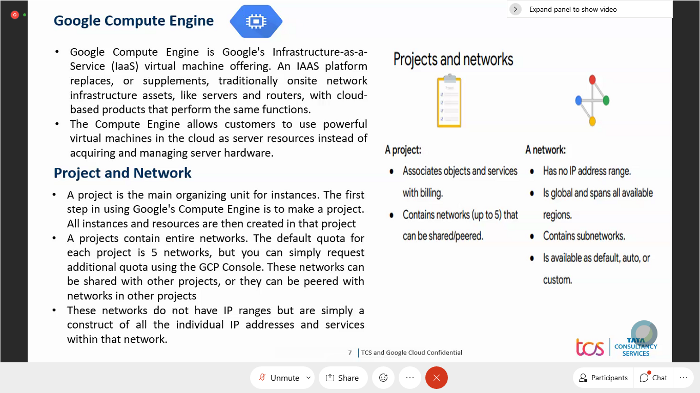

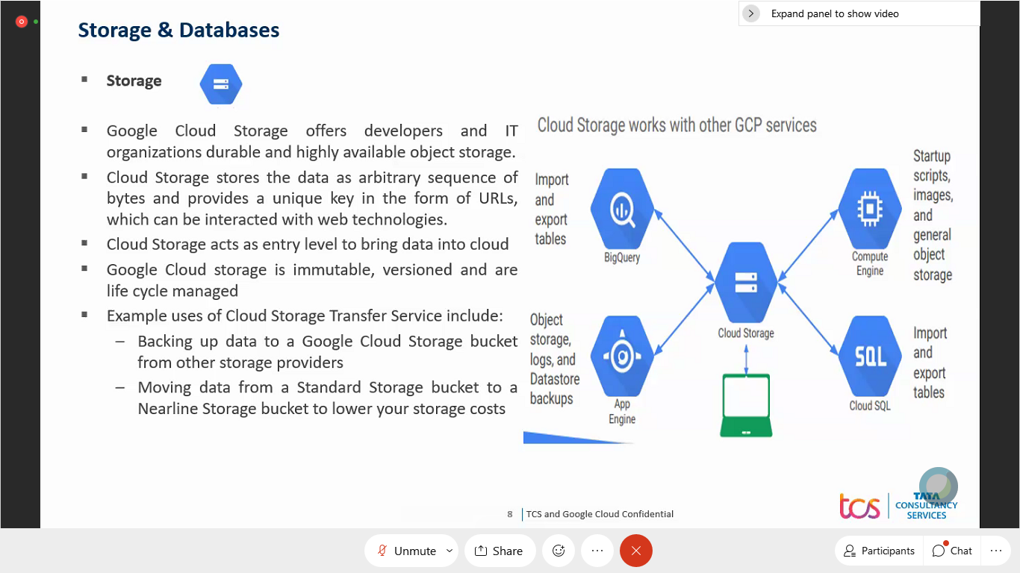

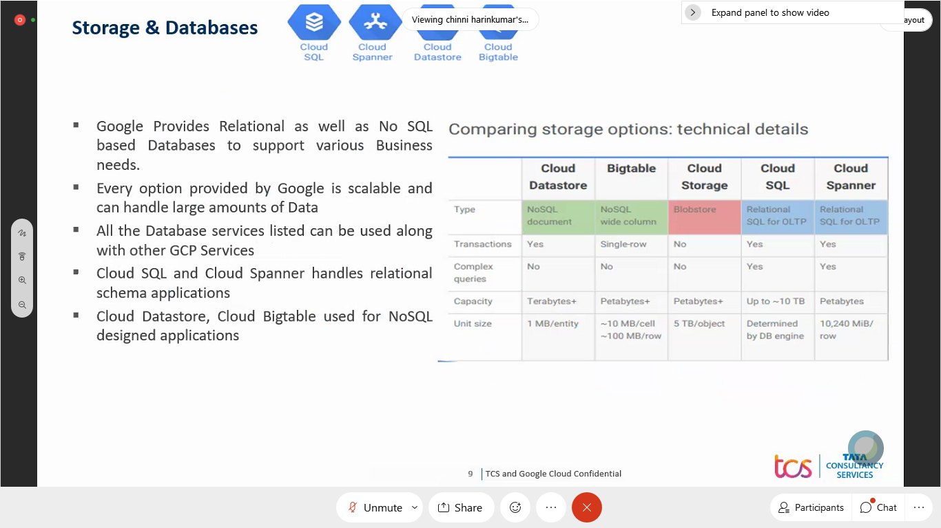

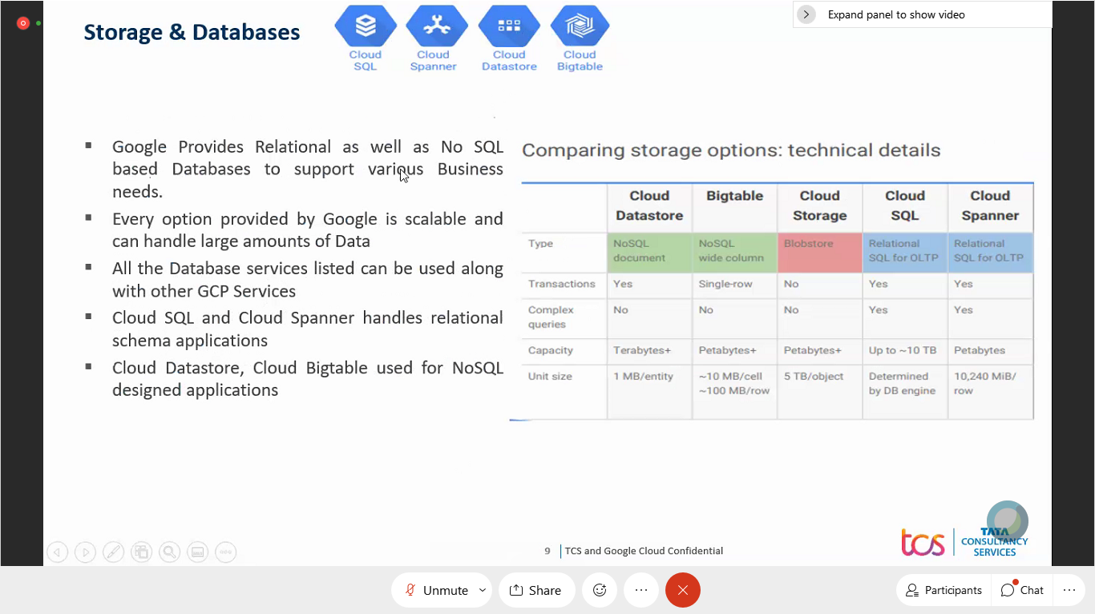

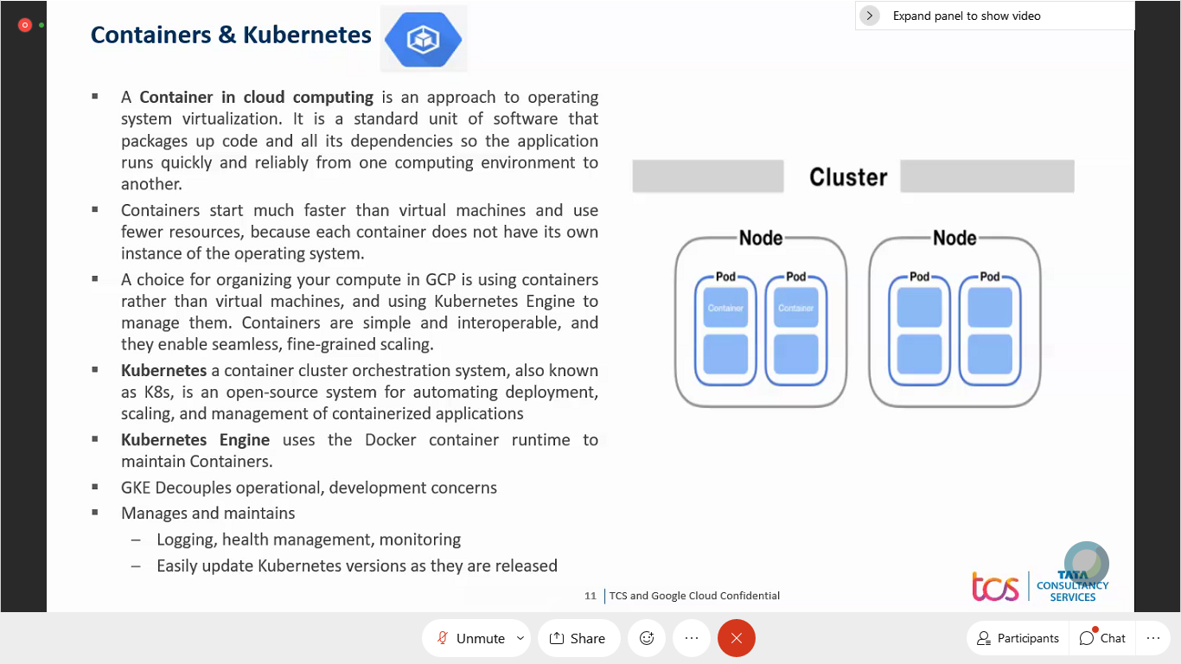

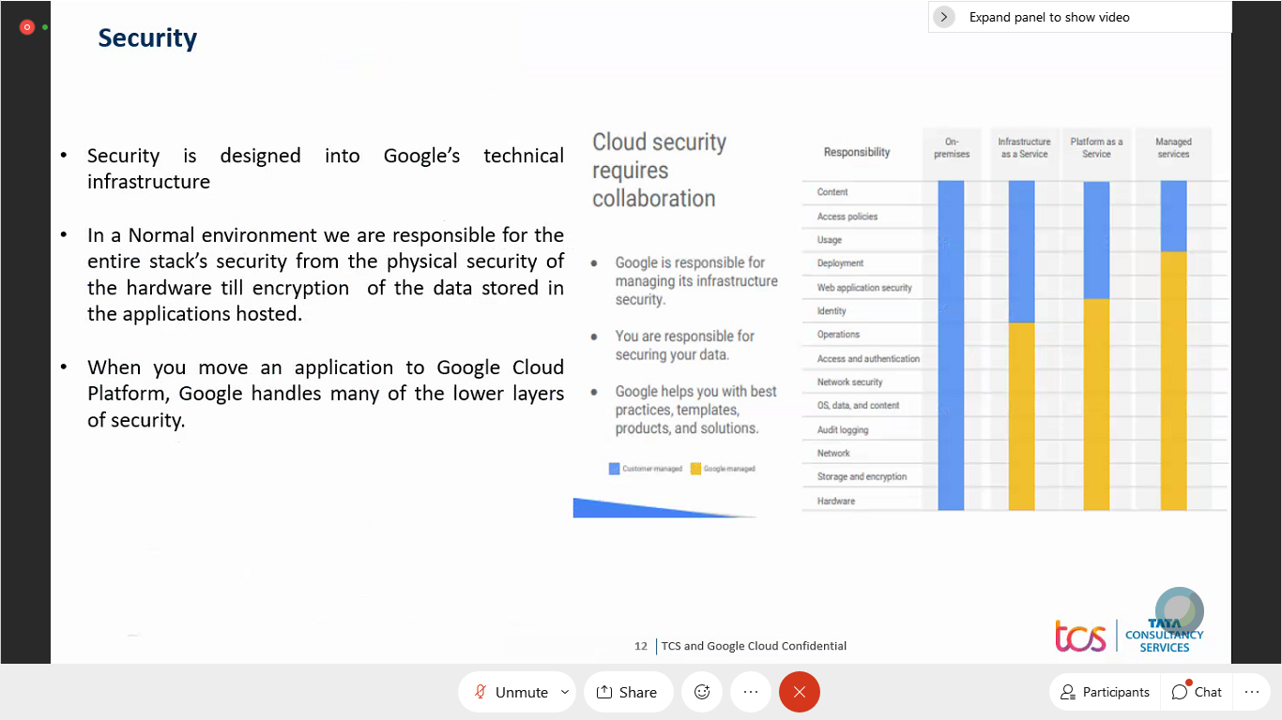

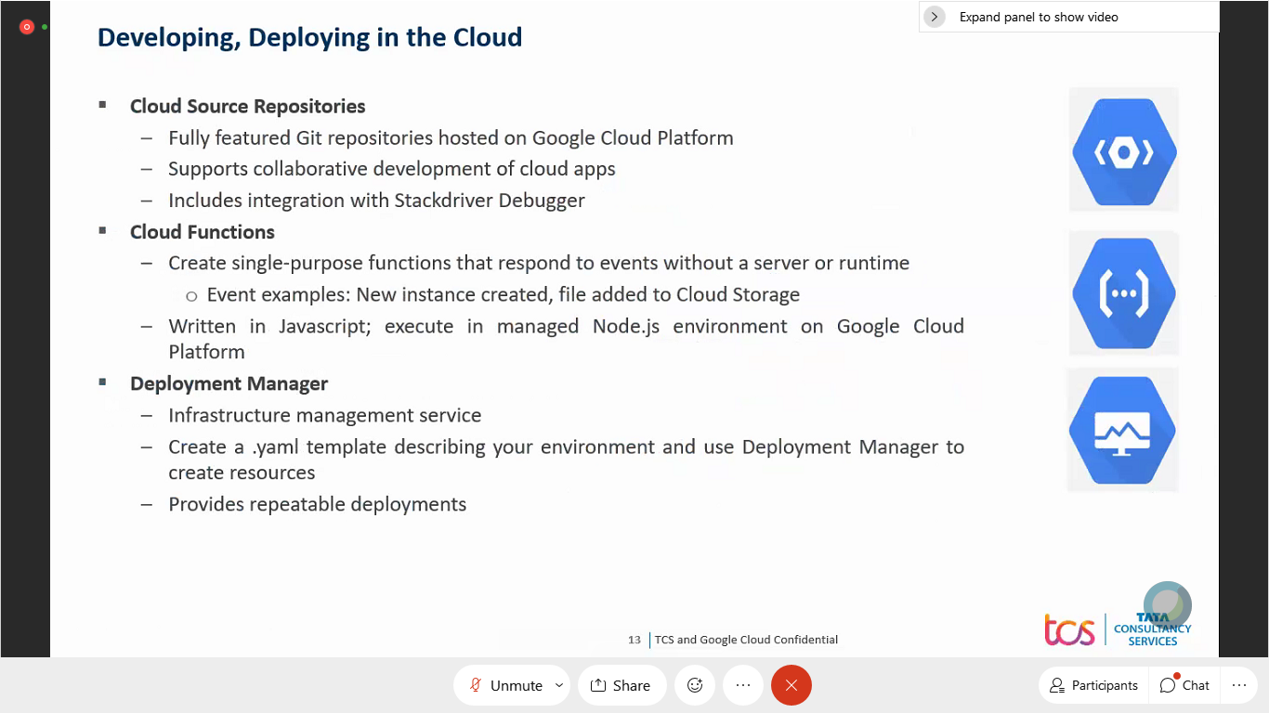

from Ramkumar Kandasamy to everyone: 2:34 PM

Hi

from Seema to everyone: 2:34 PM

Hello

from 696557_Sreelakshmi Sakivela to everyone: 2:37 PM

Hi

from 696557_Sreelakshmi Sakivela to everyone: 2:38 PM

Will you share recording after the session?

from Pinaki Aich to everyone: 2:45 PM

Hi Deepthi ..One quick question we will automatically get the welcome email ..

from sasitharan to everyone: 2:45 PM

Hi deepthi, can you share the knowmax link

from 327332_Kotesh to everyone: 2:49 PM

Will there be similar track run for PCA?

from vndpgodwin to everyone: 2:51 PM

how to we know if we completed 50% and 70% , how do you calculate it ?

from prudviraj b to everyone: 2:51 PM

yes, we will have similar sessions planned for PCA

from Saroj Gharat to everyone: 2:52 PM

Will this presenation be shared ?

from Laxmikanth to everyone: 2:55 PM

Can one associate can be enrolled to multiple courses(certifications)

from prudviraj b to everyone: 2:55 PM

only one certification can be enrolled at a time

from Laxmikanth to everyone: 2:57 PM

ok Thank you

from prudviraj b to everyone: 2:57 PM

post completion of one certification, other certification can be enabled

from 138454_ Deepthi to everyone: 3:07 PM

https://knowmax3.ultimatix.net/corpsites/bts-hsdu/GBU/SitePages/GSkool.aspx

from 138454_ Deepthi to everyone: 3:07 PM

@327332_Kotesh - yes we will have PCA starting next week

from 138454_ Deepthi to everyone: 3:08 PM

@vndpgodwin - we have uploaded the syllabus sheet in the knowmax link. this will help you with the calculation

from Pinaki Aich to everyone: 3:10 PM

Please ping the quicklab support mail id ..

from Vinit to everyone: 3:12 PM

Course link given in excel leads to deprecated course. Based on quicklab’s suggestion I look the updated course. Is that ok ? Example try https://googlecourses.qwiklabs.com/course_templates/1

from 138454_ Deepthi to everyone: 3:13 PM

@Pinaki - gsisupport@qwiklabs.com

from 538356_PallaviChoudhari to everyone: 3:16 PM

which user credentals we need to give here on webassessor

from 212763_Yogesh to everyone: 3:16 PM

You have to create by REGISTER

from 538356_PallaviChoudhari to everyone: 3:16 PM

ok

from 212763_Yogesh to everyone: 3:16 PM

Use GMAIL or TCS email any

from prudviraj b to everyone: 3:17 PM

please use TCS email id to register on Webassessor while booking exam

from 212763_Yogesh to everyone: 3:17 PM

I used by GMAIL here

from prudviraj b to everyone: 3:17 PM

only TCS email id

from prudviraj b to everyone: 3:17 PM

voucher will be given against TCS email id

from Bagesh Gupta to everyone: 3:17 PM

unable to verify my email in TCS VPN for accessing qwiklabs

from 212763_Yogesh to everyone: 3:17 PM

YES

from 212763_Yogesh to everyone: 3:18 PM

fwd TCS to gmail that link

from Bagesh Gupta to everyone: 3:18 PM

sorry!!

from R K V Sekhar Babu Sirigudi to everyone: 3:21 PM

I have received Google Cloud learning resources on 01/31, by when I should be completing the courses to take Certifcation?

from 212763_Yogesh to everyone: 3:21 PM

6 week

from Sandesh T to everyone: 3:22 PM

Previously I was registered for Professional Cloud Architect, I see those courses but not Associate Cloud Engineer. Where can I see learning path for Associate Cloud Engineer?

from 212763_Yogesh to everyone: 3:25 PM

Associate Cloud Engineer

from 212763_Yogesh to everyone: 3:25 PM

search this

from Jamsheedh CV to everyone: 3:36 PM

All the meetings will be in webex only,right? not in teams for next week,right?

from prudviraj b to everyone: 3:36 PM

yes, it will be on Webex

from Jamsheedh CV to everyone: 3:36 PM

Thanks Prudvi

from Lisit Thakkar to everyone: 3:39 PM

please share this Knowmax link here

from Sam to everyone: 3:39 PM

I am getting an error in the first training module: it says I don't have permission to view a youtube video.

from Sam to everyone: 3:45 PM

What was the solution for accessing the youtube videos on your TCS asset?

from 138454_ Deepthi to everyone: 3:45 PM

@Venkatesan - once you complete 70%, you will get voucher and then register for exam.

from Govind Krishnan to everyone: 3:46 PM

Where are the CR category and other CR details mentioned based on which we can raise the CR for accessing the google youtube videos in the course?

from 138454_ Deepthi to everyone: 3:46 PM

@Sam - we need to raise CRs. There is some confusion with in IS team, so we will share the process in knowmax link once it is frozen

from vndpgodwin to everyone: 3:47 PM

Do we have a AWS drive or program similar to this GCP drive in TCS now ?

from Govind Krishnan to everyone: 3:47 PM

ok, deepthi. Would also appreciate a TEAMS broadcast and/or message through L&D spocs like Vishakha Rana for North America. Thanks

from Govind Krishnan to everyone: 3:48 PM

@ Deepthi- that was for the CR process

from 986387_RAHULKUMAR to everyone: 3:49 PM

I don't have TCS MS teams with TCS mail ID. Can I join the teams group using client MS TEams???

from Jeetu Burman to everyone: 3:50 PM

if possible, can you adjust your mic harin

from Sam to everyone: 3:50 PM

@Deepthi - Thanks. How do you mean you will share the information in Knowmax. Do you mean you will share it in the Gskool page or in the GCP Learning Resources documents?

from Sam to everyone: 3:51 PM

Can you also share the link to the MS Teams

from 138454_ Deepthi to everyone: 3:52 PM

in the GCP Learning Resources documents

from R K V Sekhar Babu Sirigudi to everyone: 3:52 PM

yes Audible

from 138454_ Deepthi to everyone: 3:53 PM

https://teams.microsoft.com/l/channel/19%3aeeb7307609754df889d60e43b18ac013%40thread.tacv2/Learners%2520Space?groupId=d2829dc8-b0ad-4c1a-b1cb-65fa0b098f49&tenantId=404b1967-6507-45ab-8a6d-7374a3f478be

from 180250 to everyone: 3:58 PM

Hi Deepthi, i did not gte the invite for MSTeams yet. is it still in the process to configure the IDs?

from Karan Arora to everyone: 3:59 PM

Hello, would you be able to share direct link to courses within qwiklabs for 'Professional Cloud Developer(Beta) Certification' ?

from Raminder Kaur to everyone: 4:00 PM

i also did not get the invite for MSTeams yet

from Deepesh Shah to everyone: 4:00 PM

I cannot see any resource in Qwiklab account.

from Deepesh Shah to everyone: 4:01 PM

I even tried with the link given in the excel sheet but it threw an error "Sorry, access denied to this resource."

from 138454_ Deepthi to everyone: 4:04 PM

You can enroll yourself in teams channel

from 138454_ Deepthi to everyone: 4:04 PM

for access denied issue, please raise it with google support

from sabitha pulivarthi to everyone: 4:05 PM

mail to gsisupport@qwiklabs.com for access denied issue

from 138454_ Deepthi to everyone: 4:05 PM

https://teams.microsoft.com/l/team/19%3a3adb21ce924d4b3bb30f4f3fbd0d246d%40thread.tacv2/conversations?groupId=d2829dc8-b0ad-4c1a-b1cb-65fa0b098f49&tenantId=404b1967-6507-45ab-8a6d-7374a3f478be

from 180250 to everyone: 4:11 PM

I am using Teams on my mobile so i think you need to add me to the respective channel OR let me know the steps to enroll to the learning channel

from 138454_ Deepthi to everyone: 4:12 PM

ok

from K Krishna Teja to everyone: 4:12 PM

deos the order of last name and first name matter while registering for exam? As generally it takes lastname and firstname seperately but usually lastname is displayed after firstname but in actual document proof my firstname comes after last name..

from 986387_RAHULKUMAR to everyone: 4:13 PM

@deepthi I don't have TCS MS Teams and unable to join the channel. Need your help

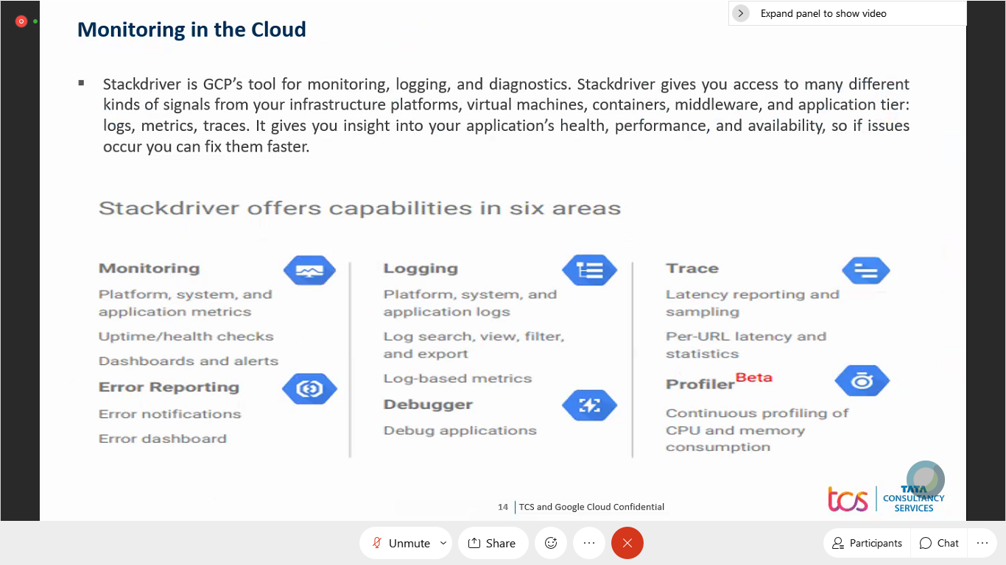

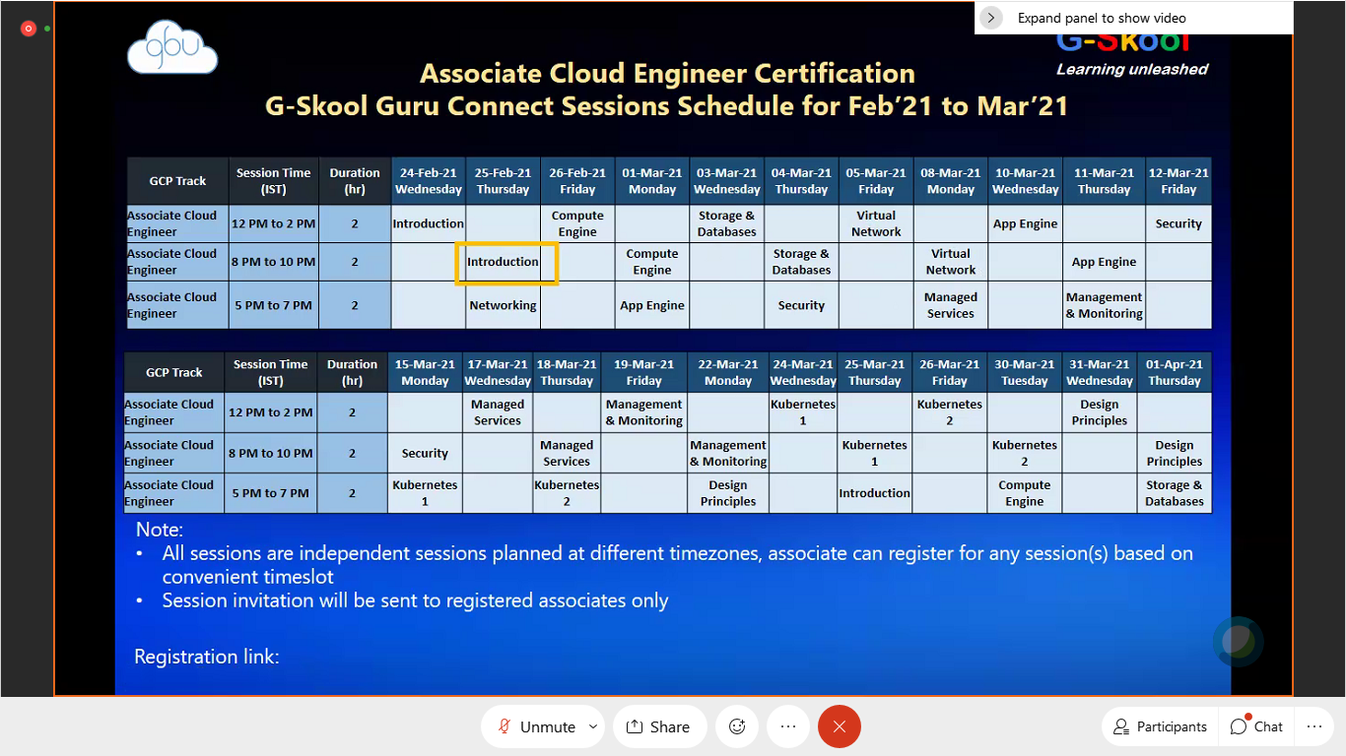

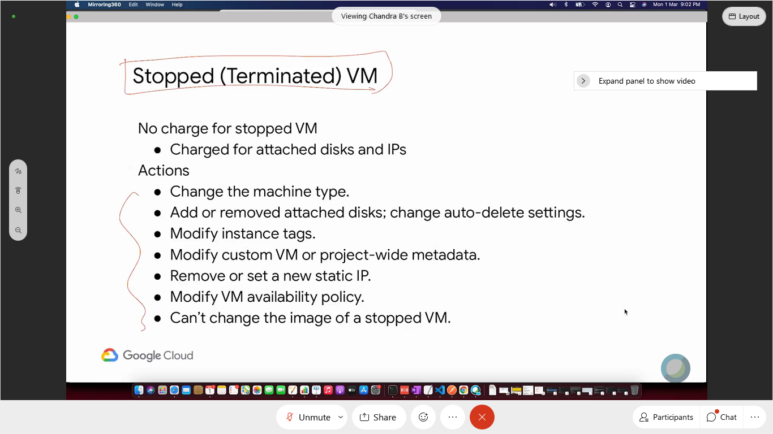

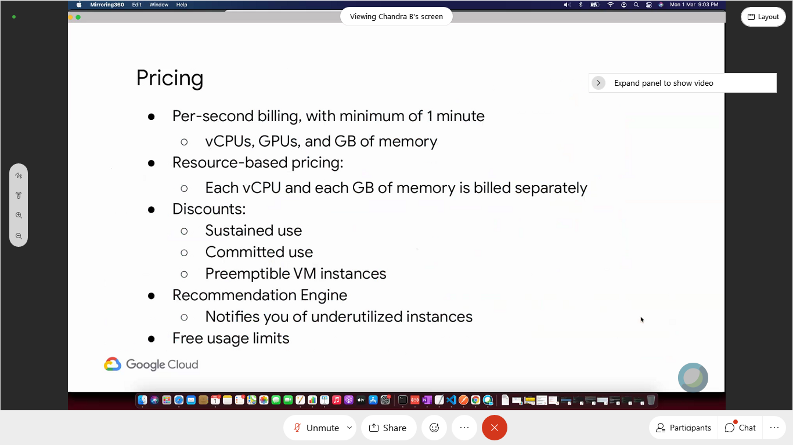

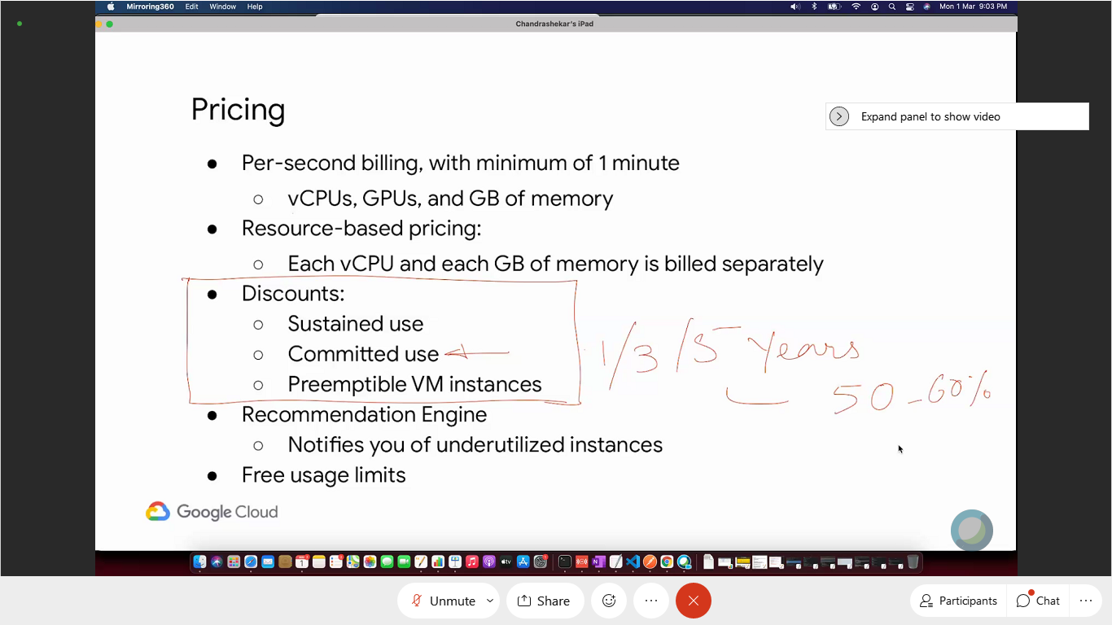

vM chargedrom start to terminate

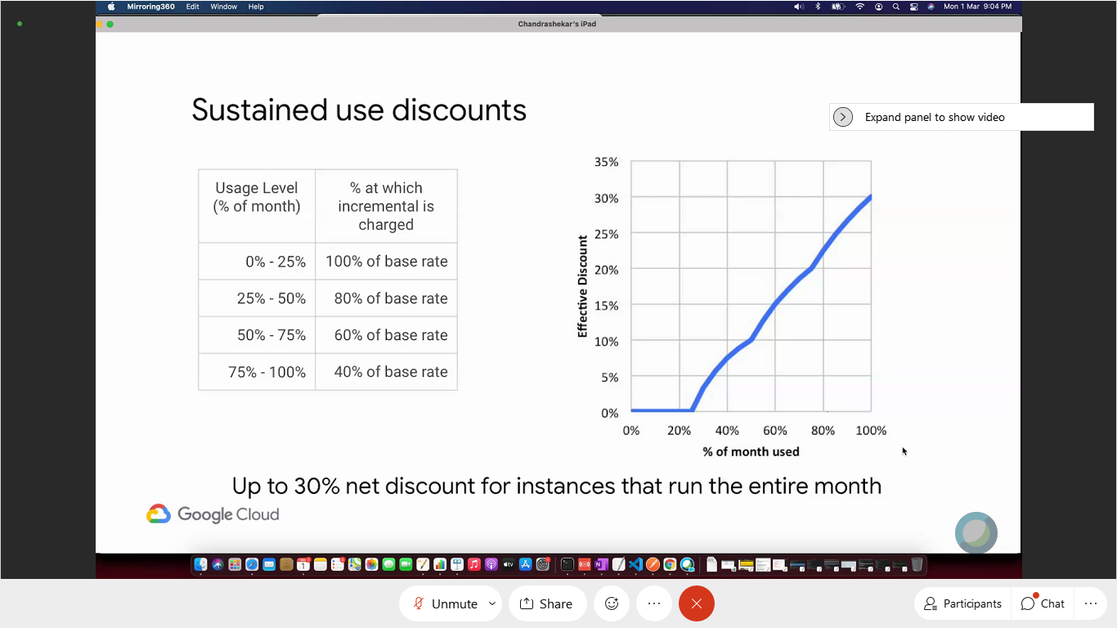

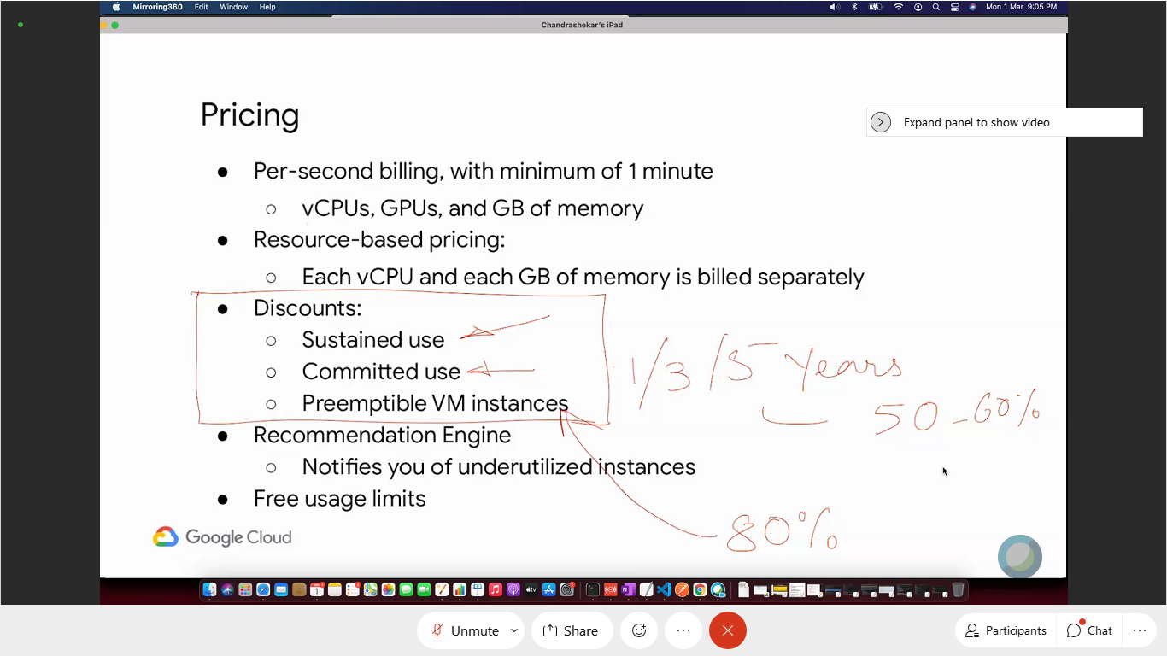

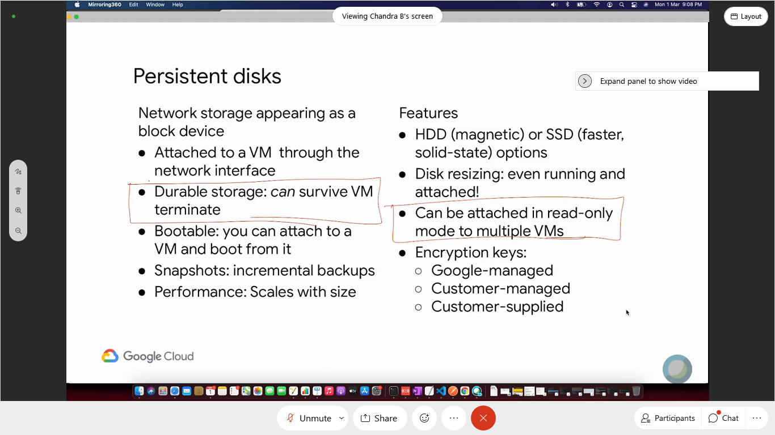

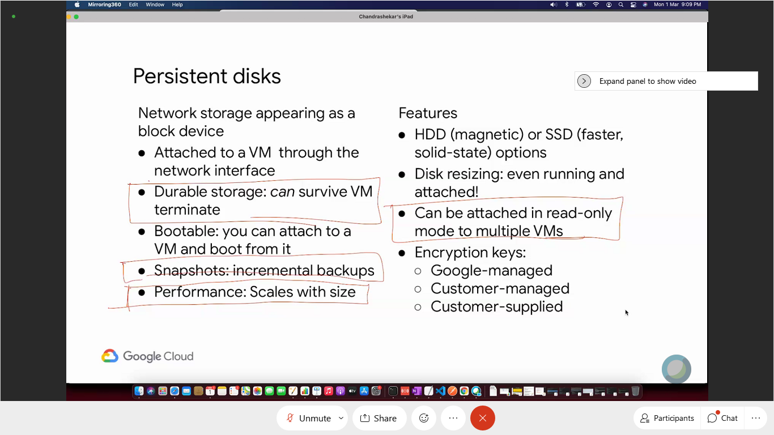

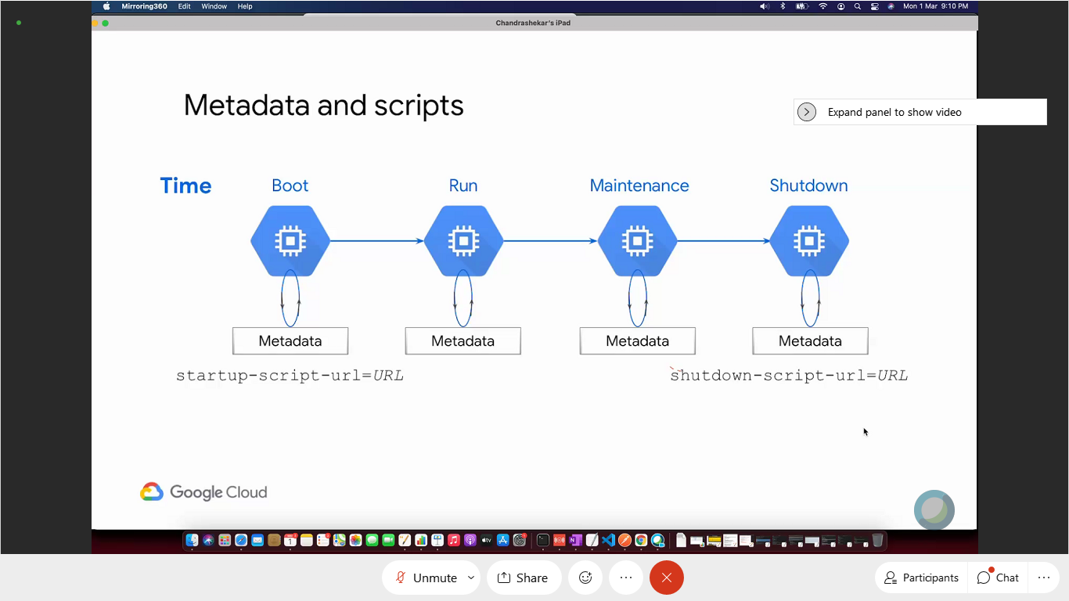

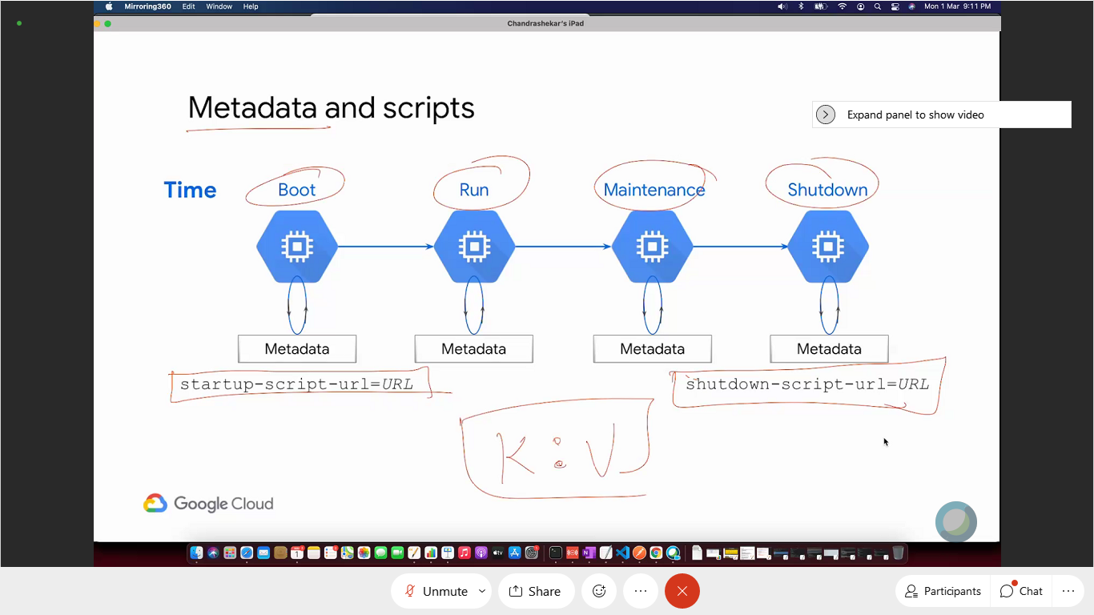

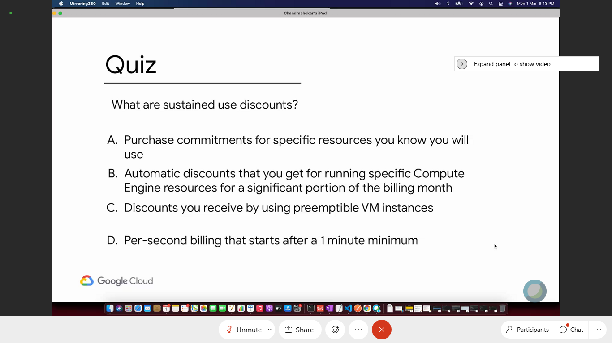

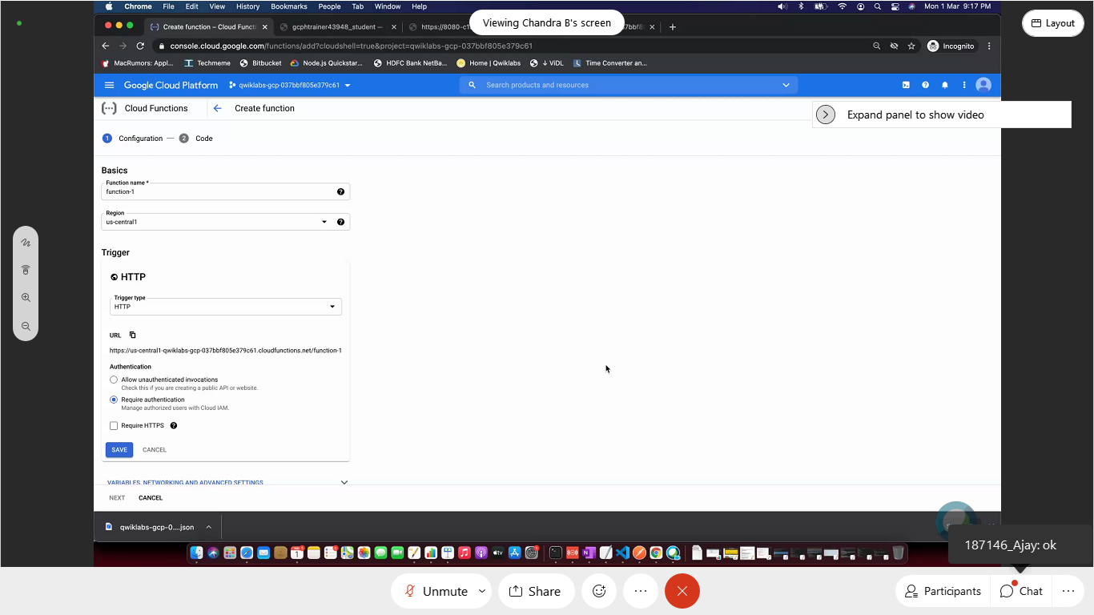

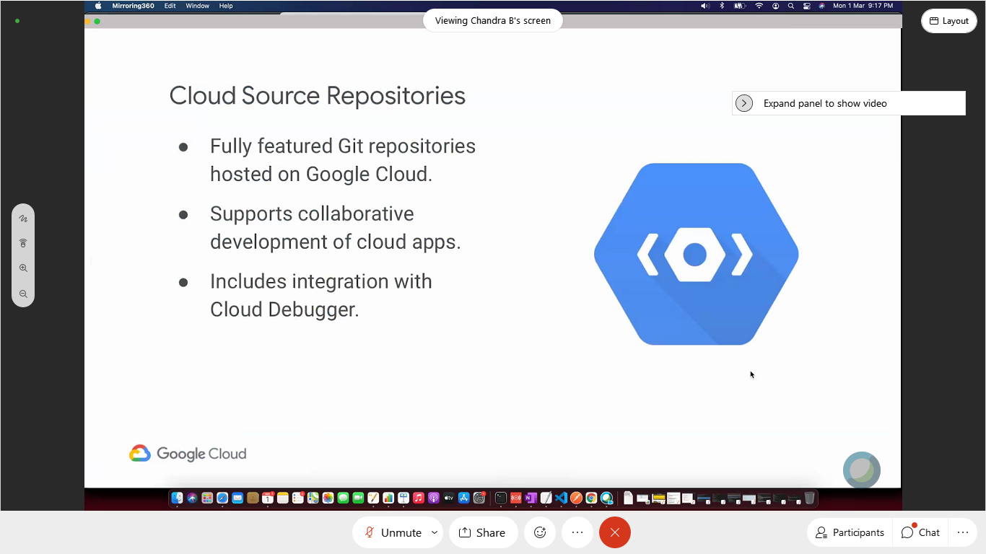

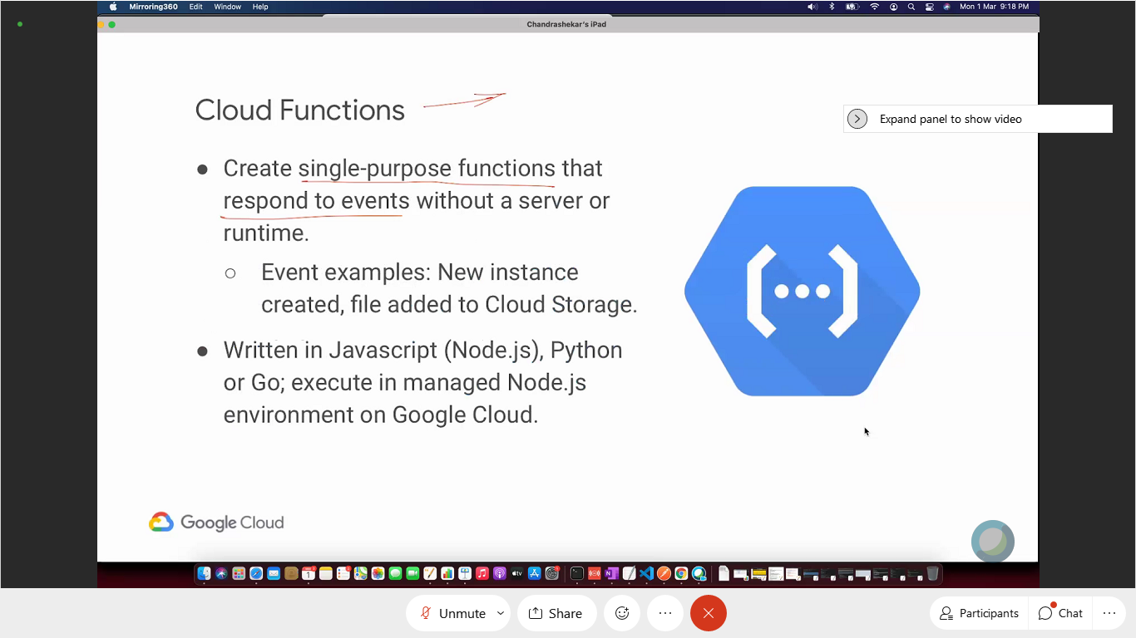

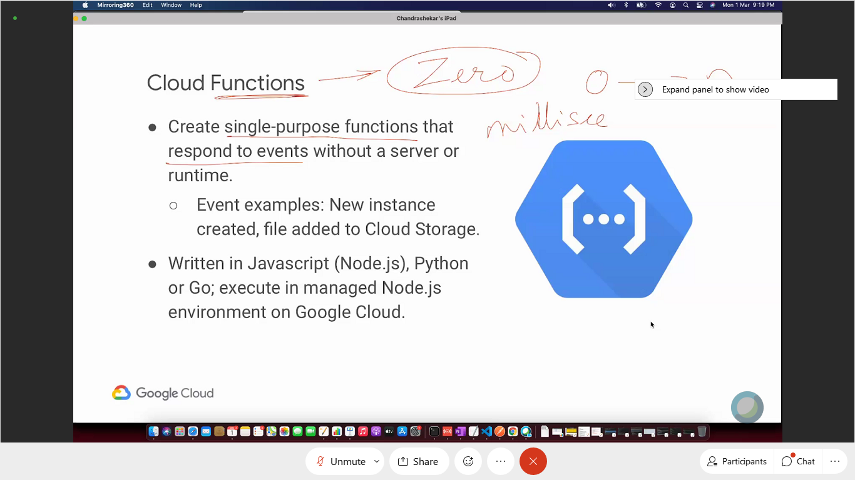

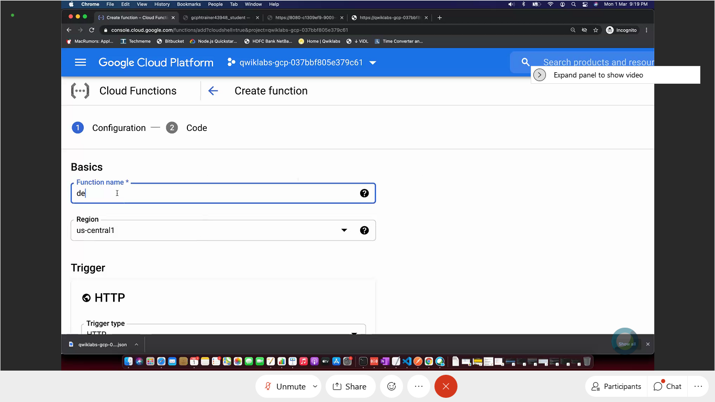

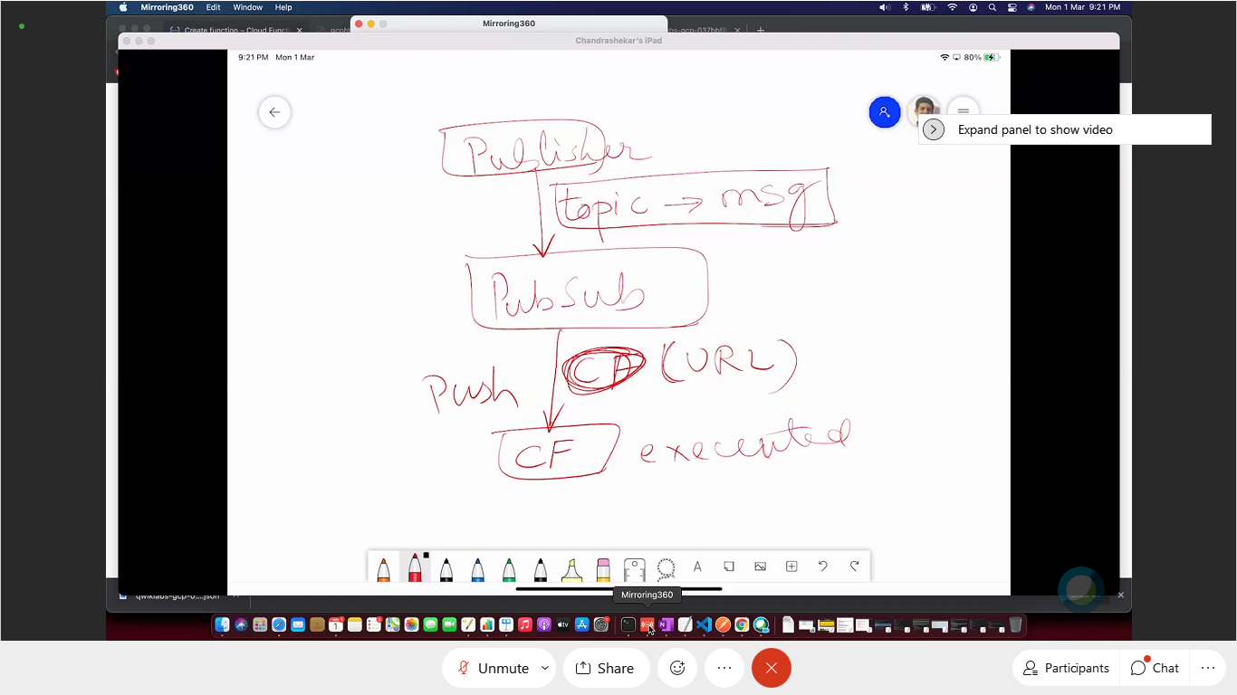

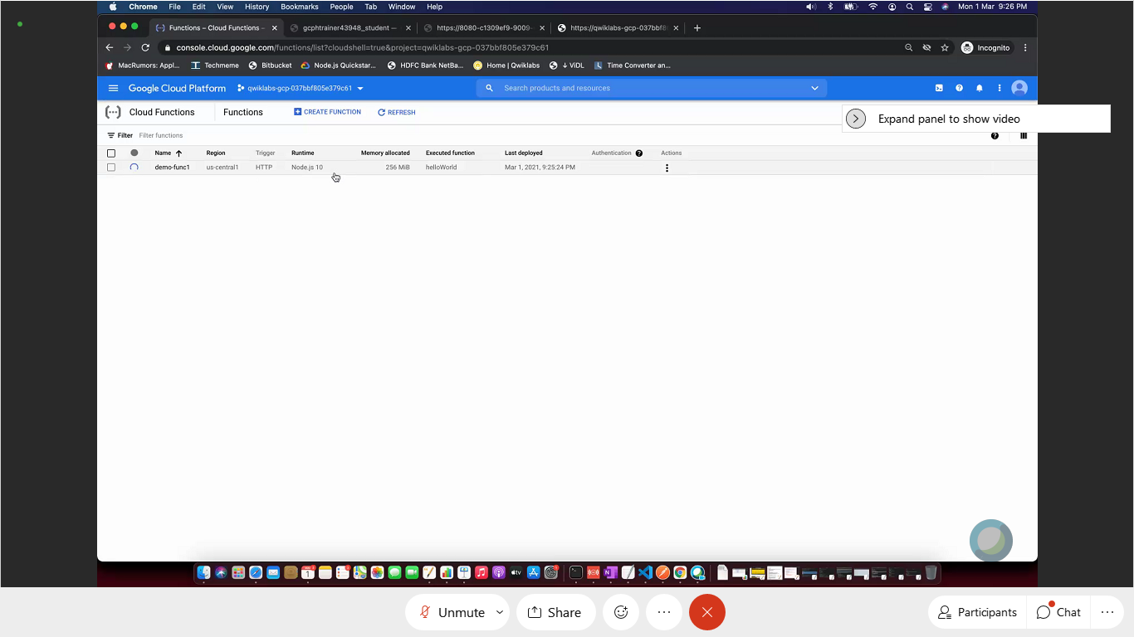

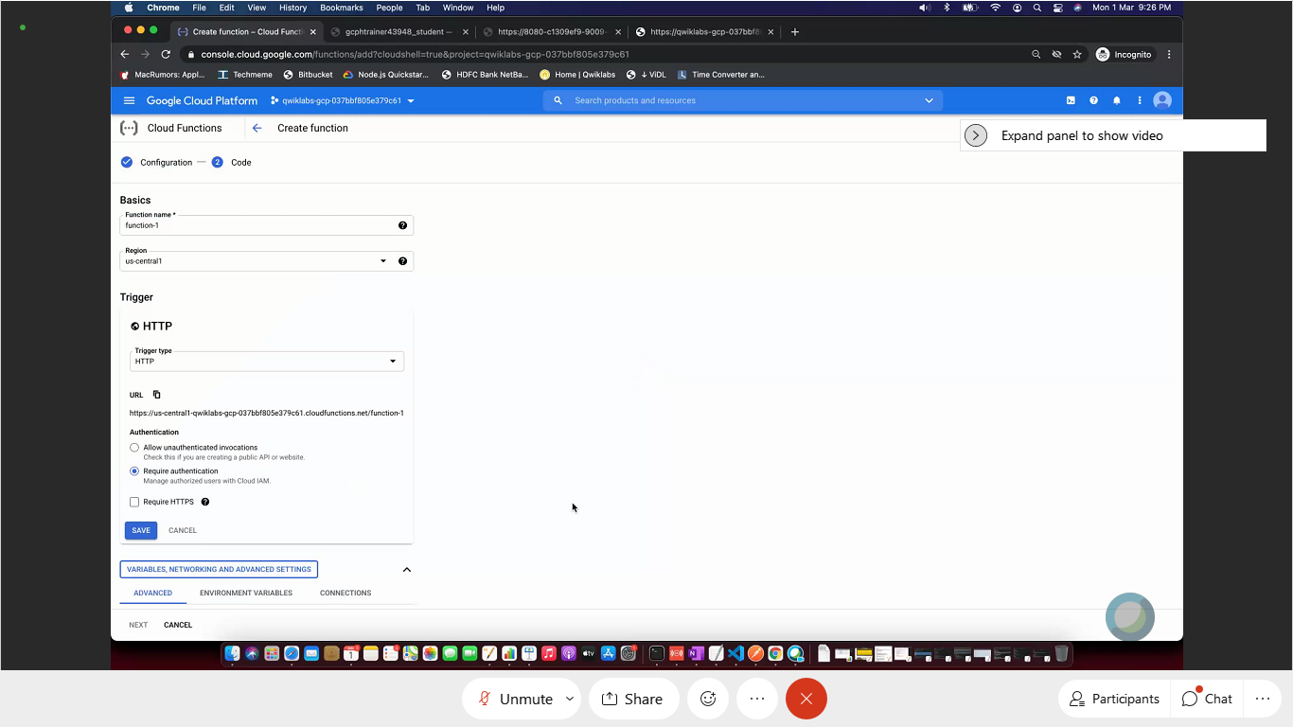

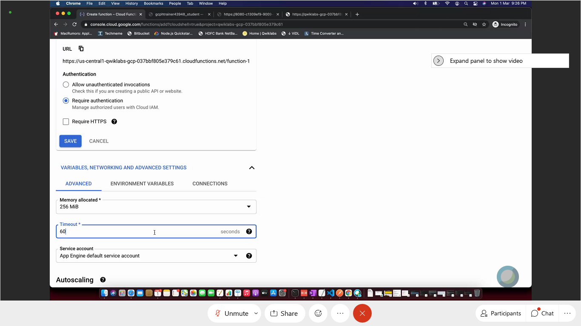

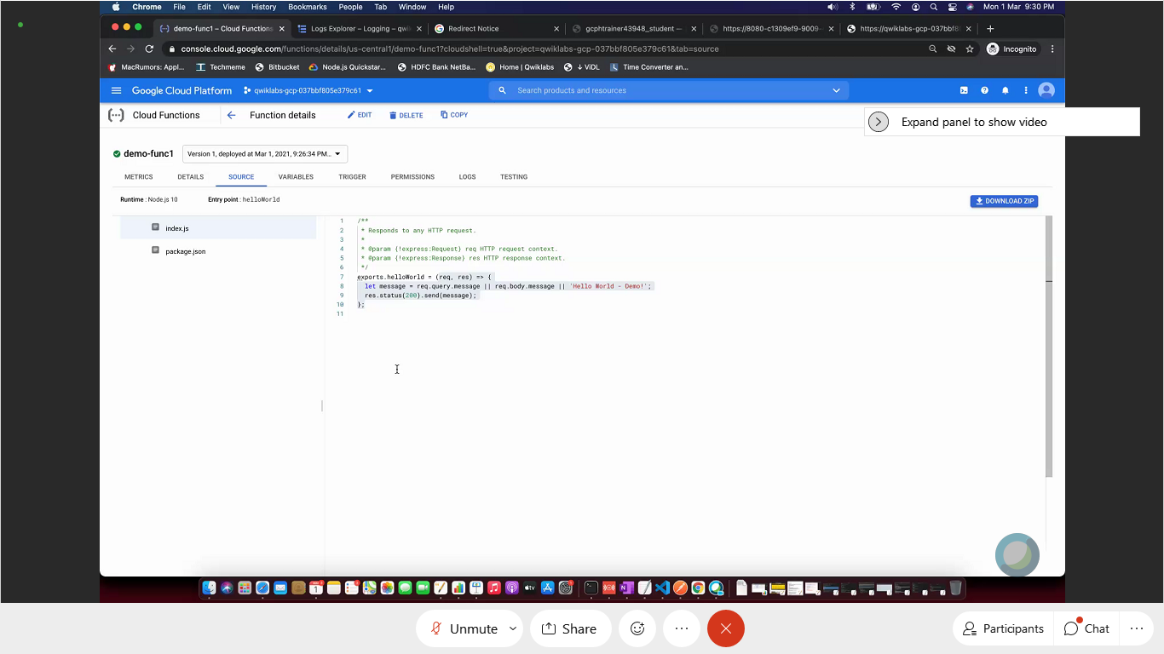

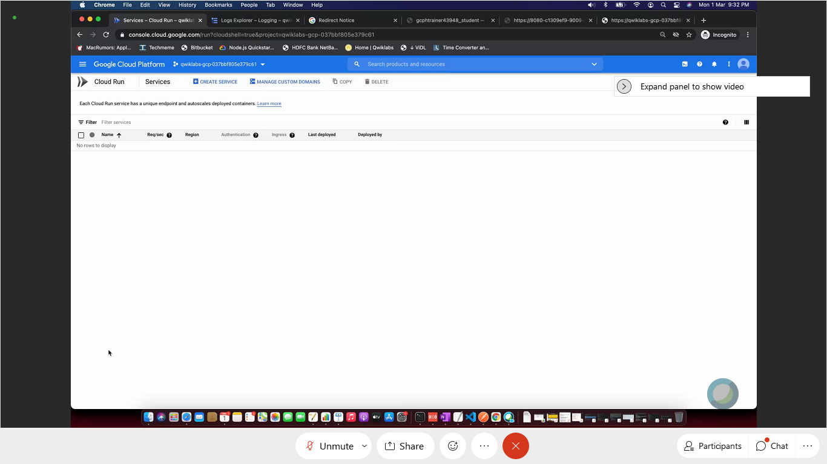

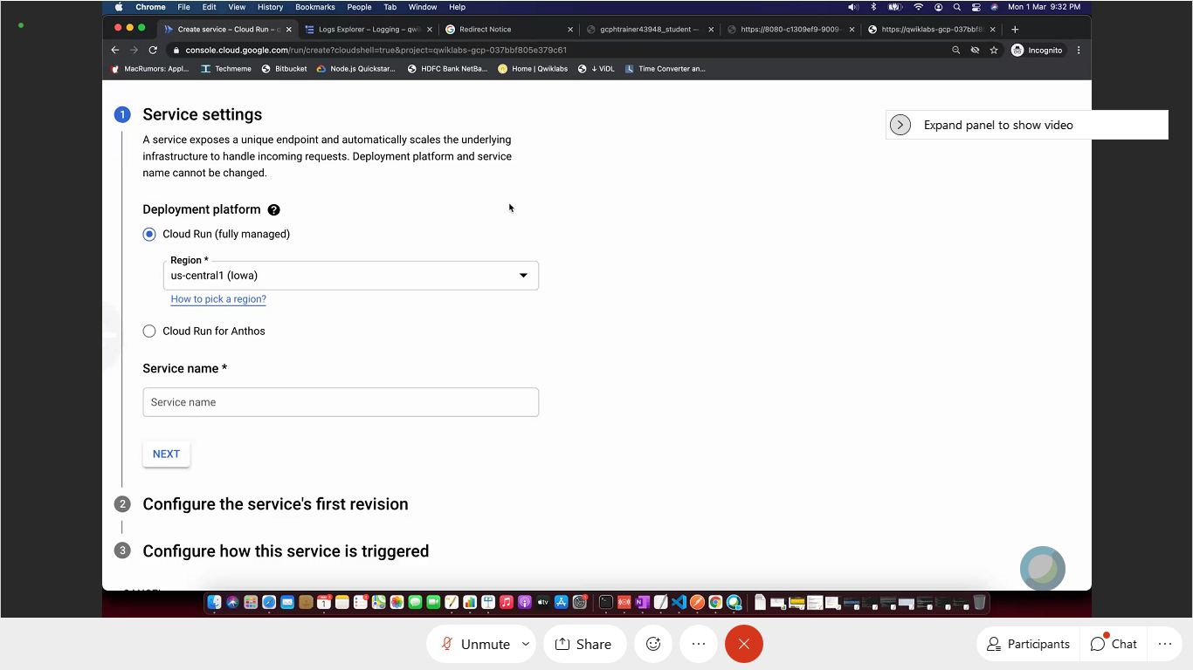

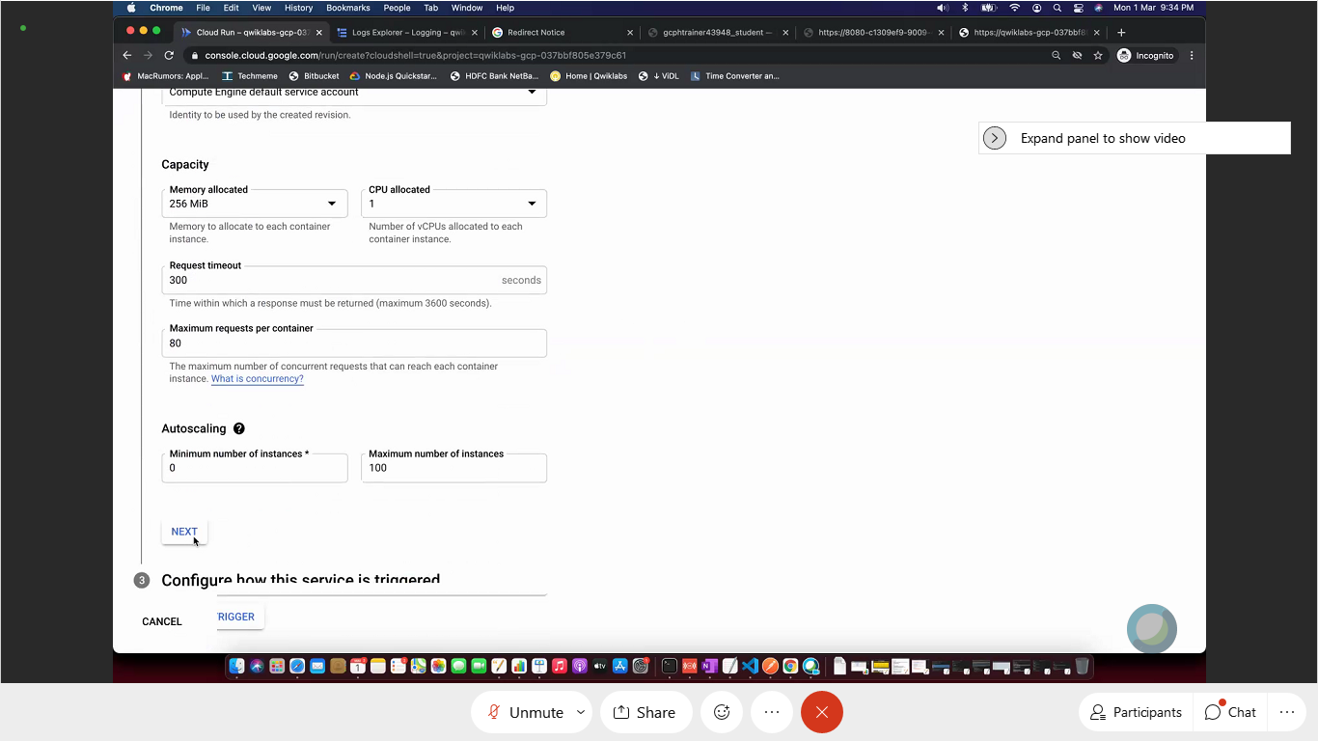

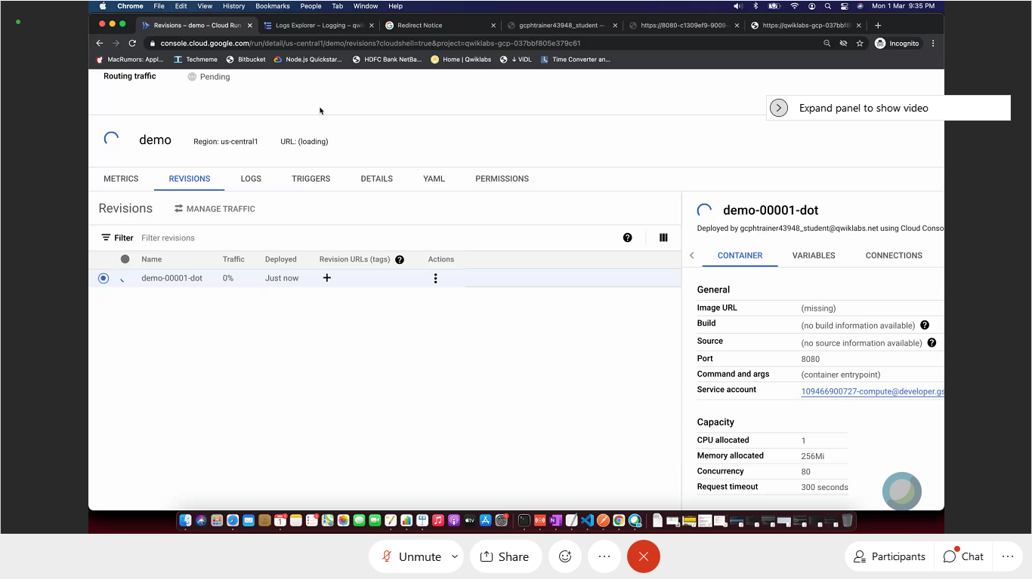

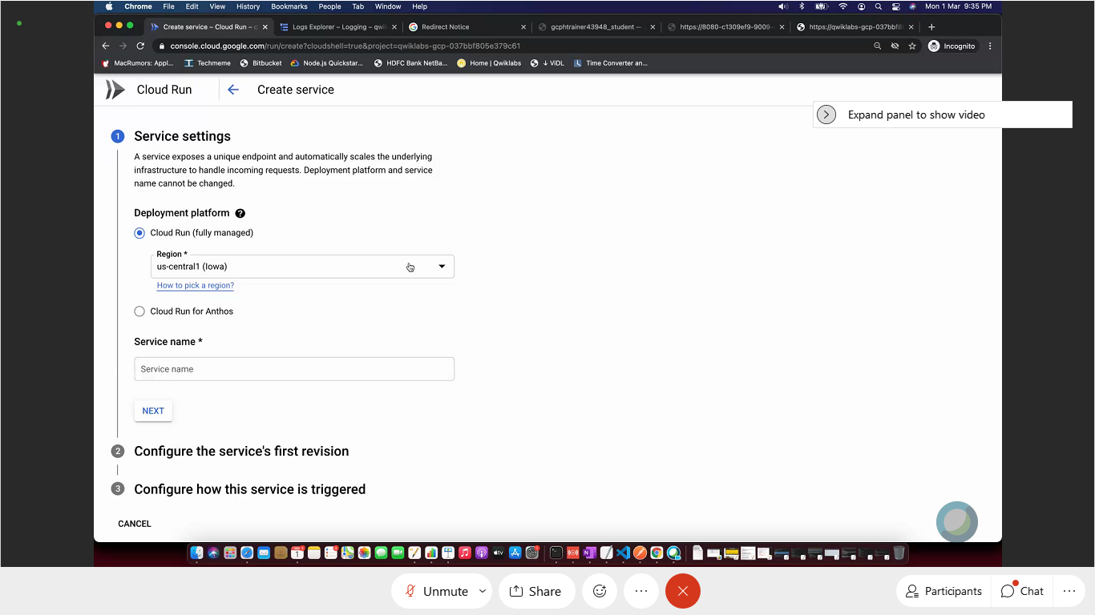

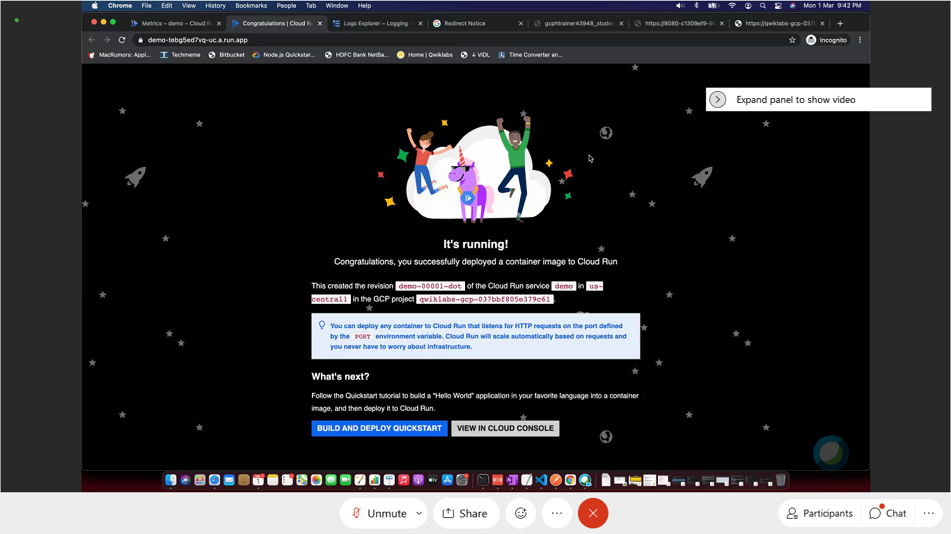

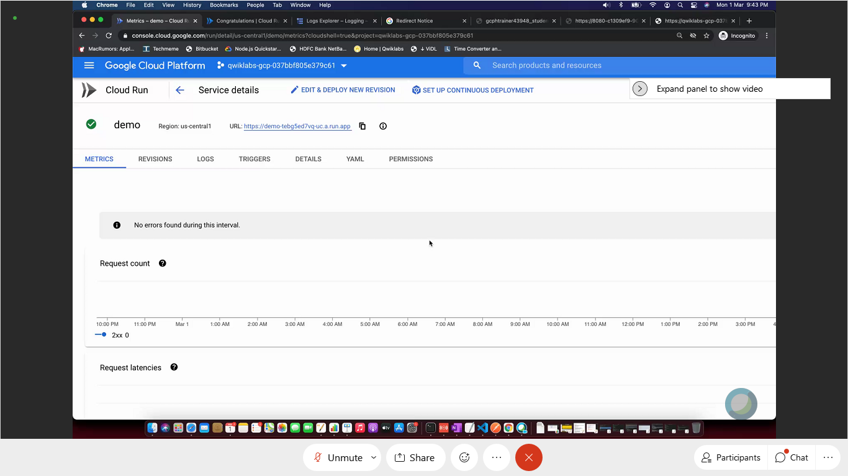

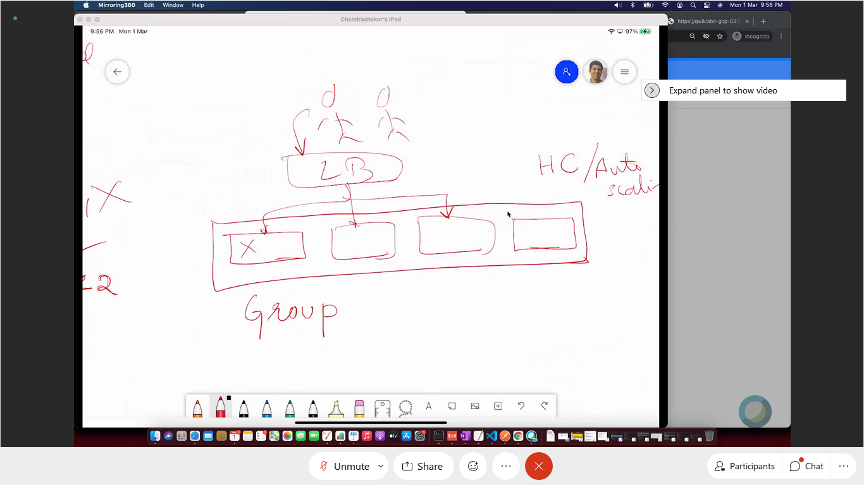

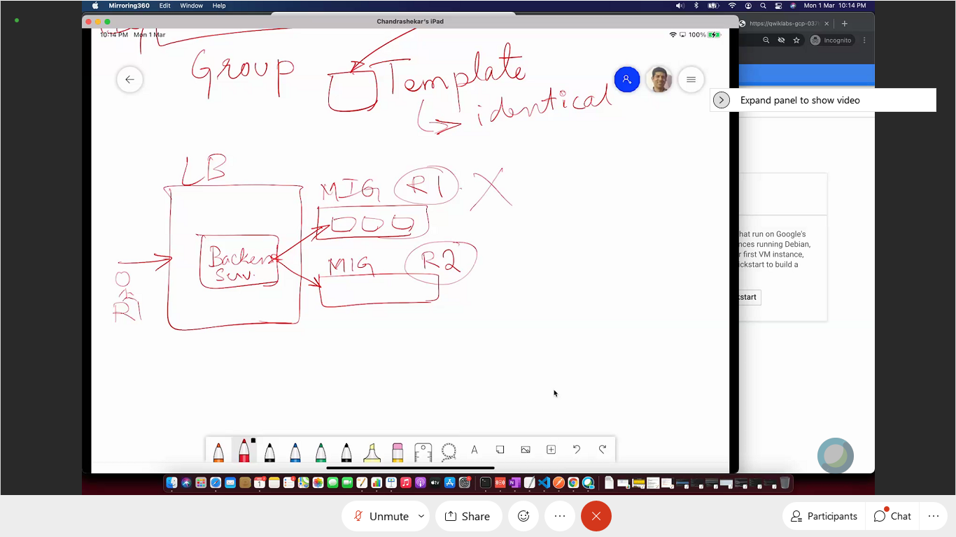

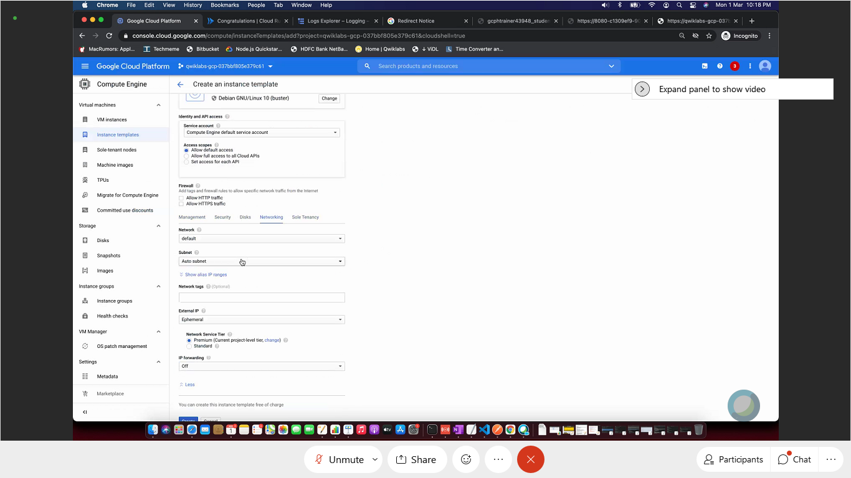

Chandra P

++++++++++++++++++++++++++++++++++++++++++++

04 Mar. 21

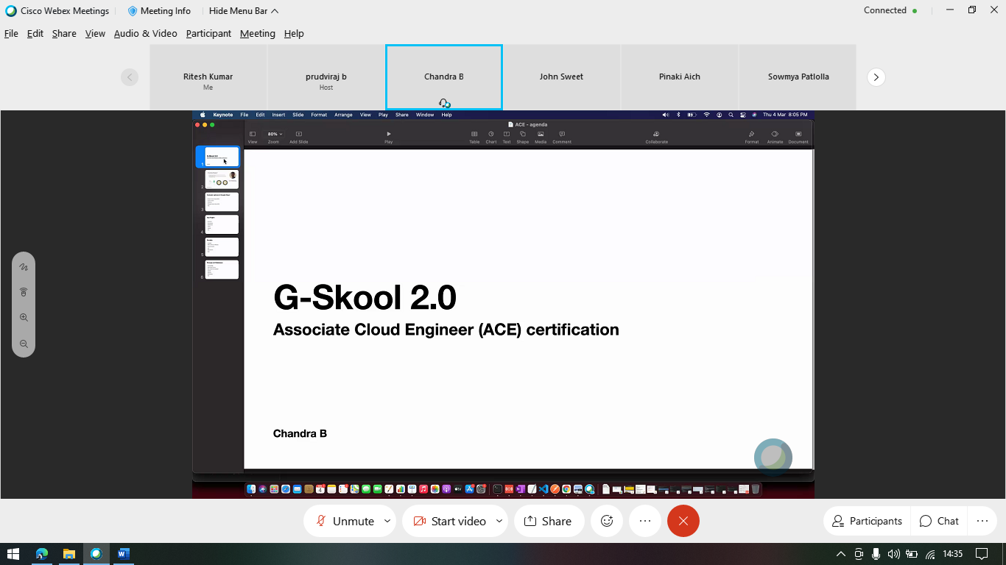

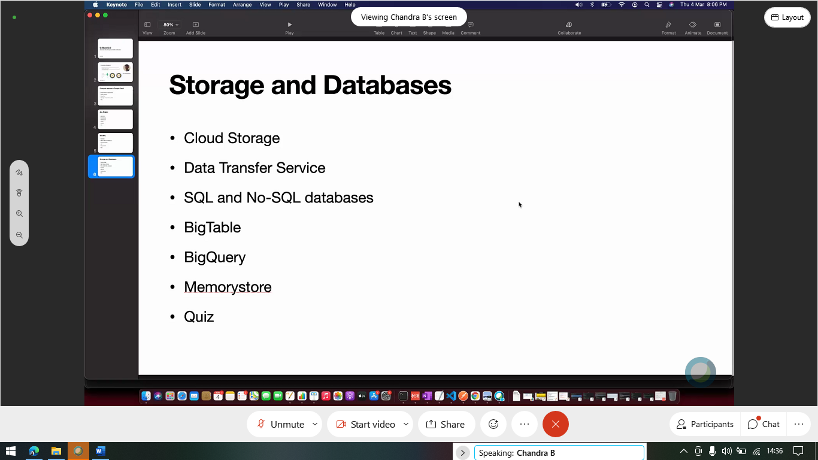

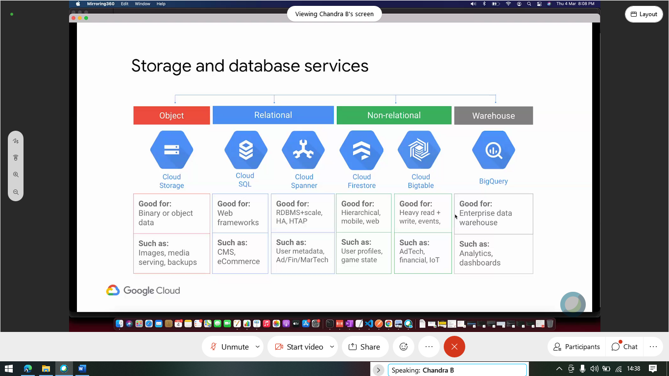

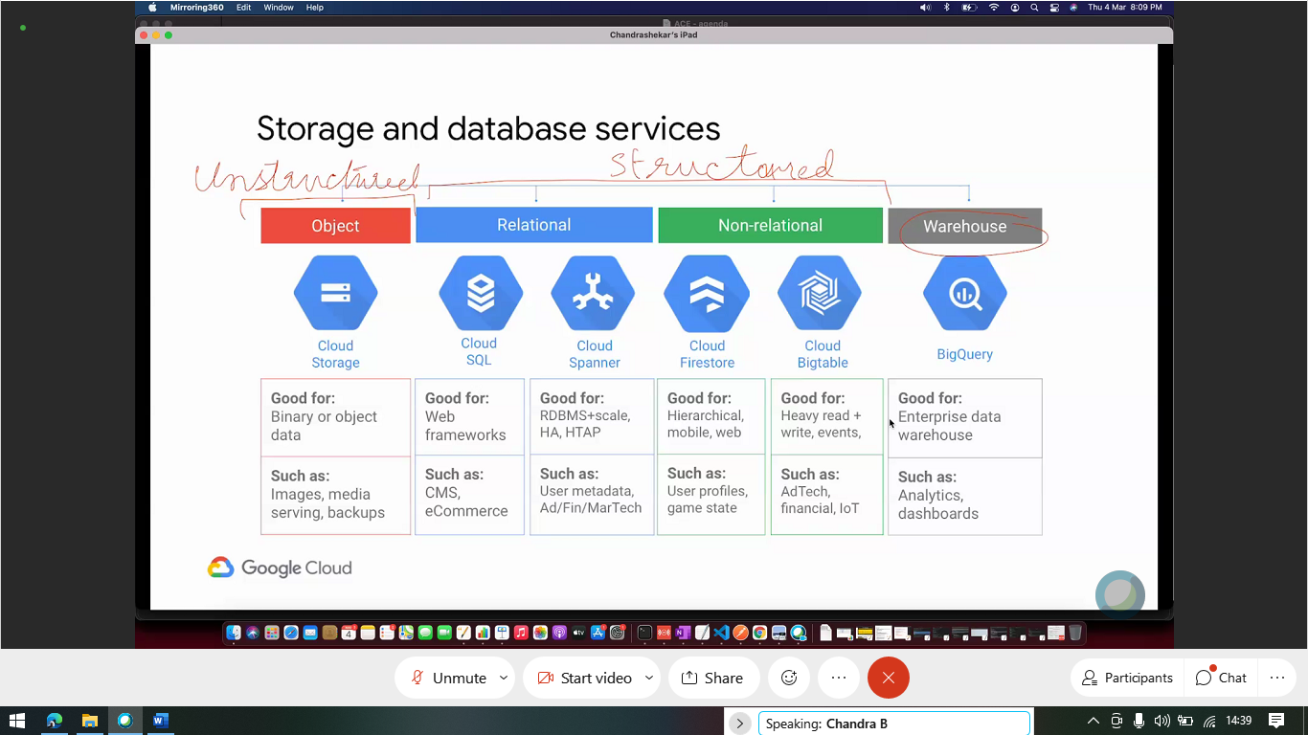

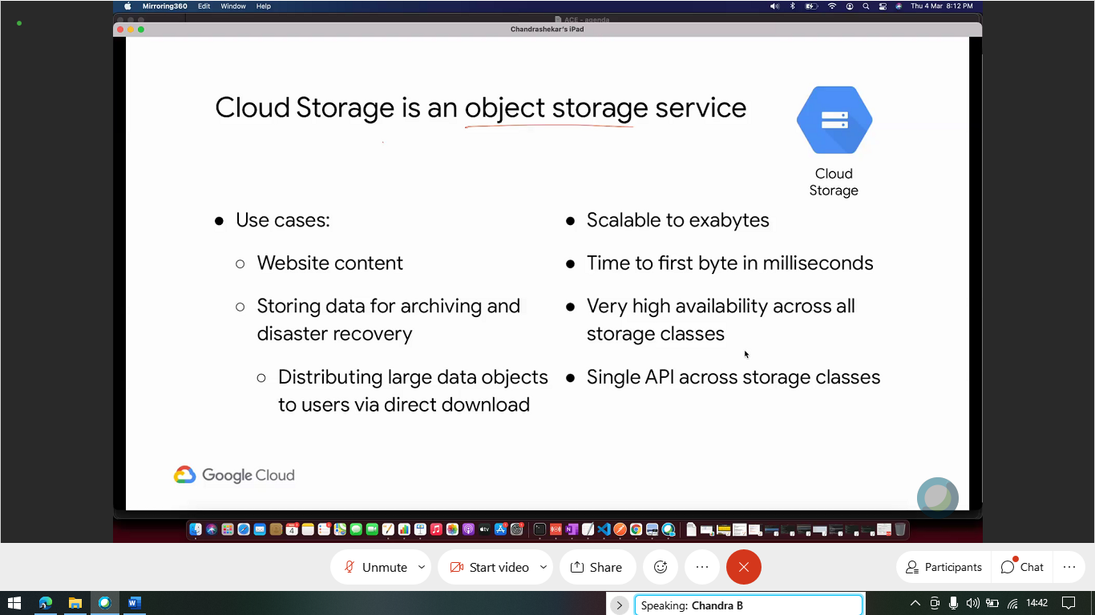

In cloud storage (object storage service) – you create buckets that stores objects (or files). Objects can’t be modified (immutable). Highly reliable. Versioning is used for modification.

Blob – big binary objects.

You can have multiple regional buckets. – Availability, low latency.

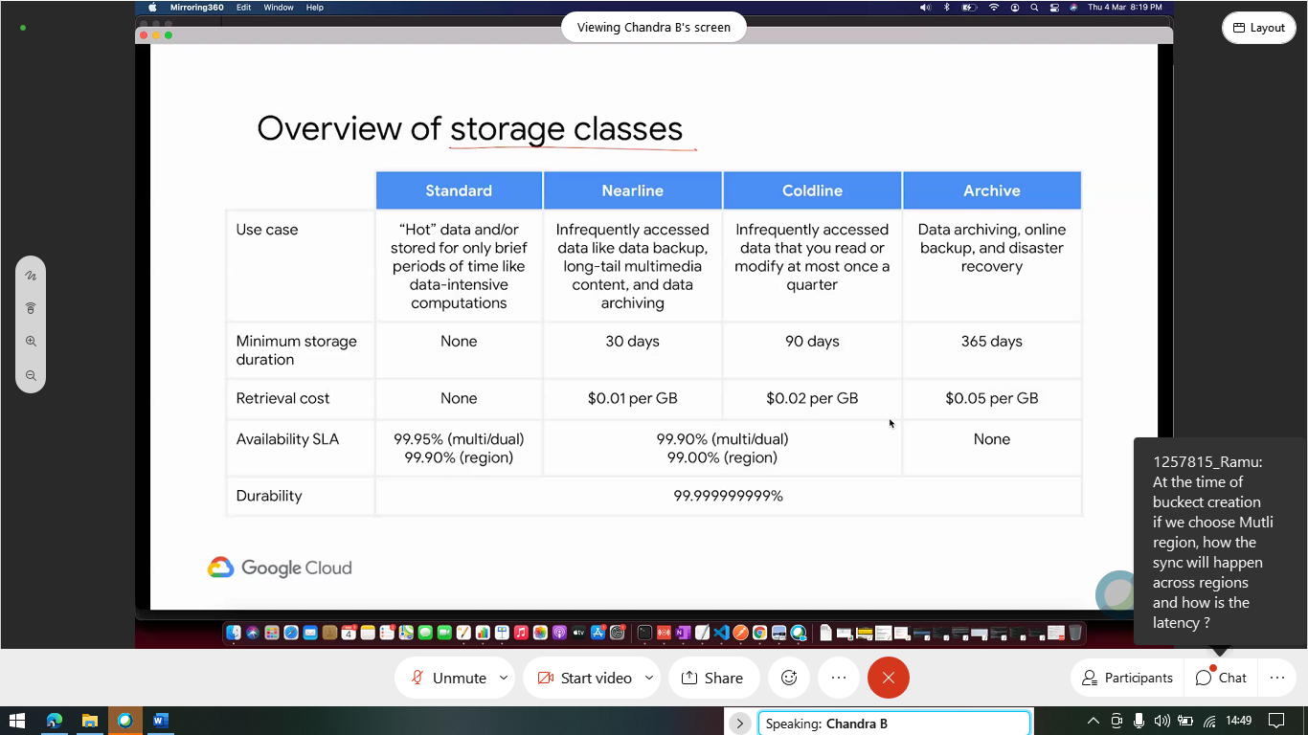

Choosing class is important for monetary purpose.

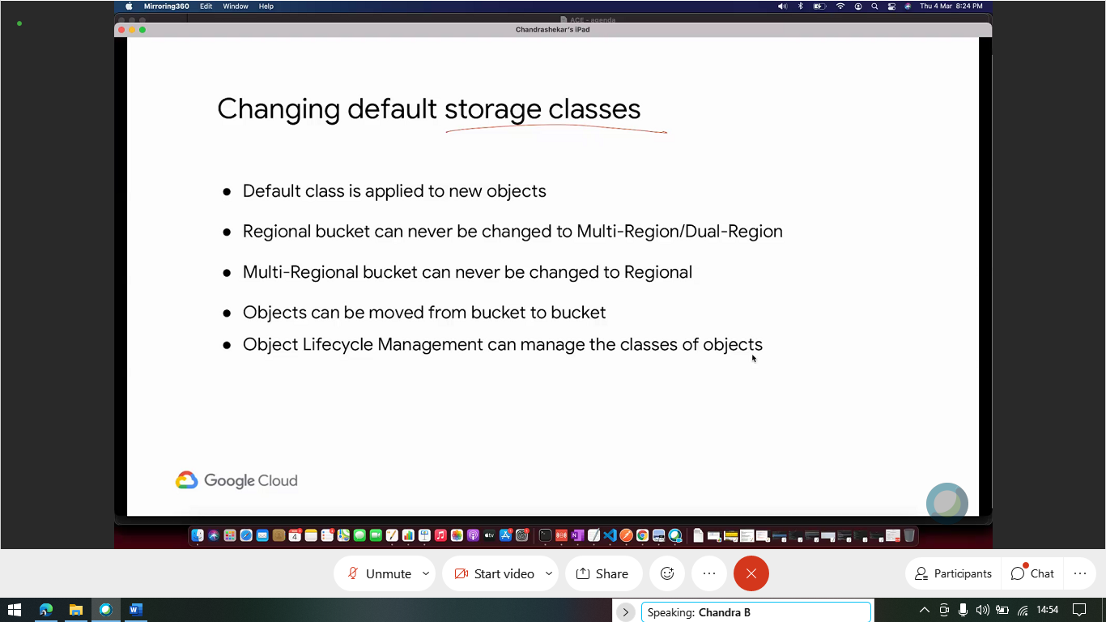

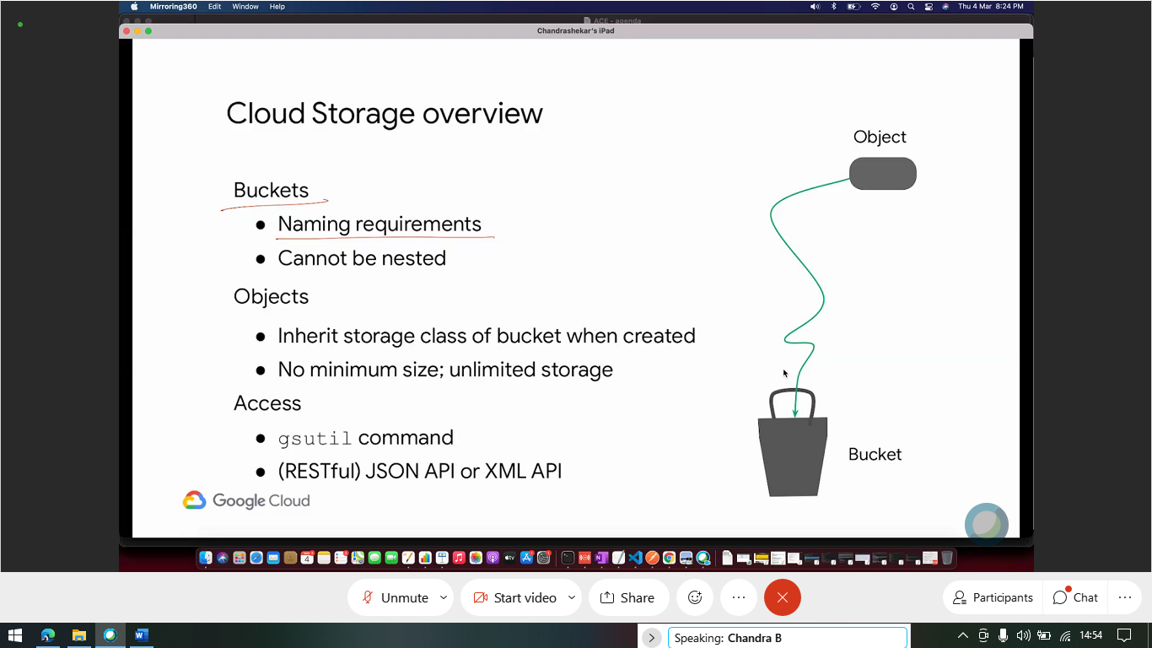

Object have class of bucket, but can be changed during Object life cycle management dynamically.

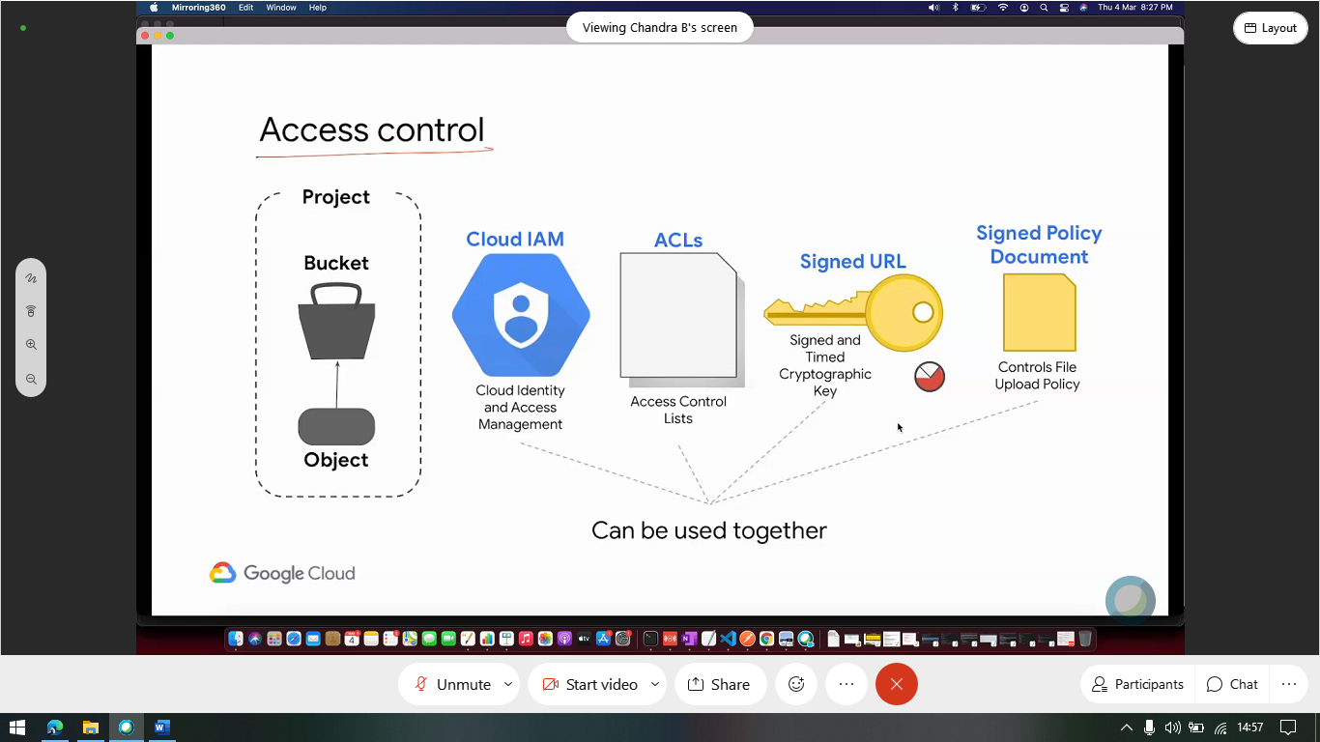

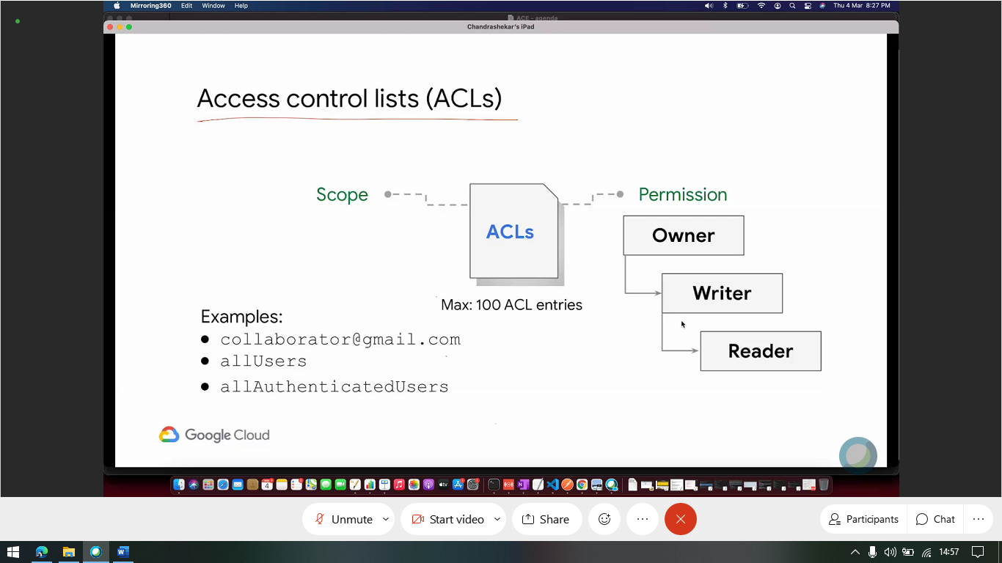

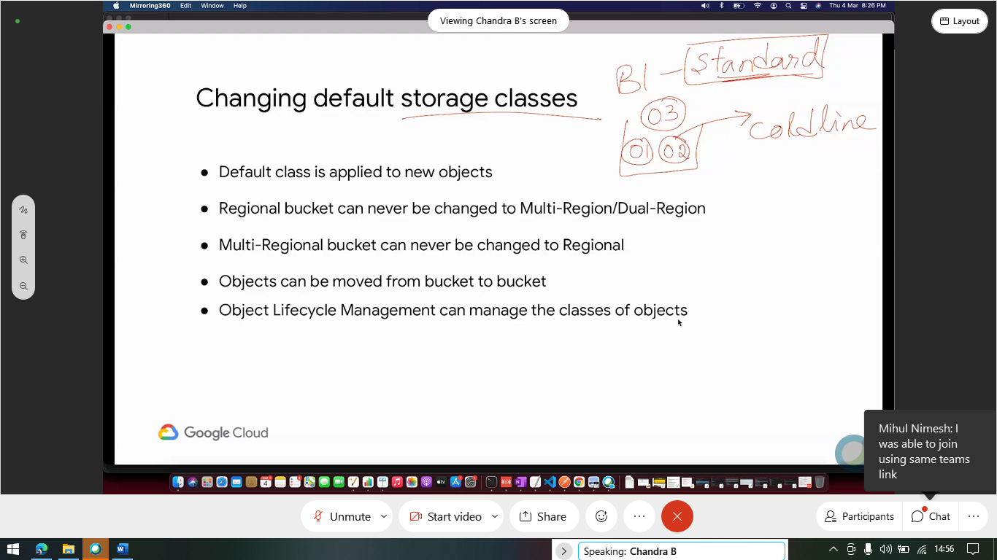

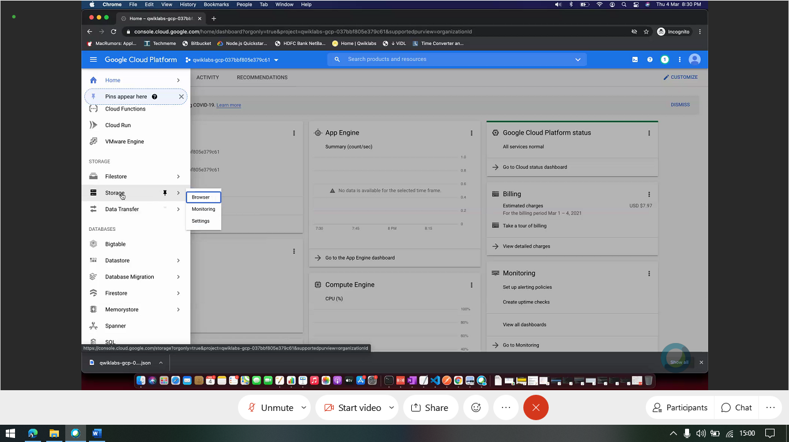

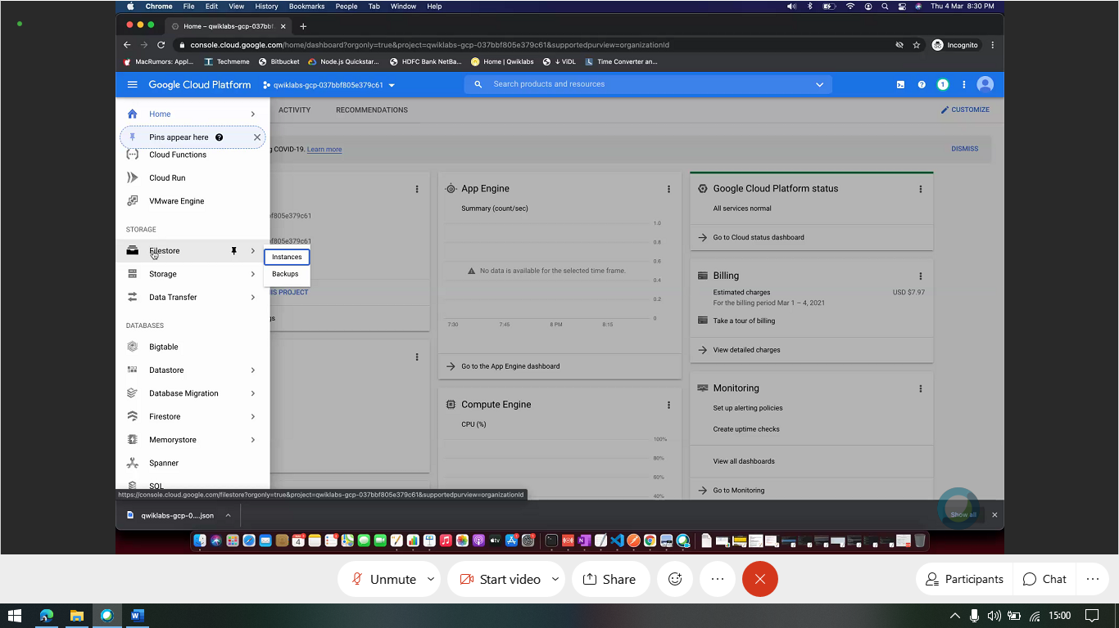

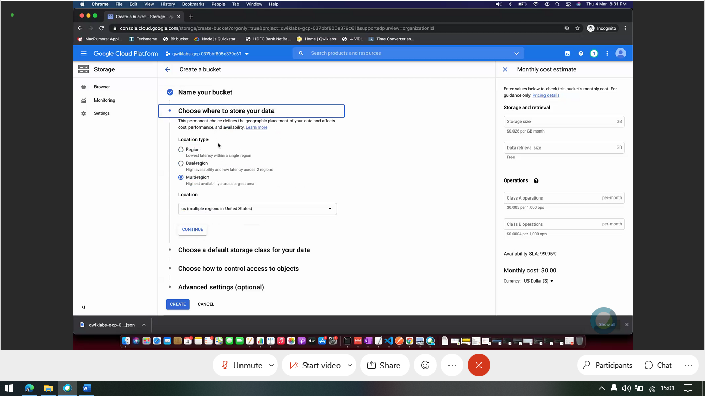

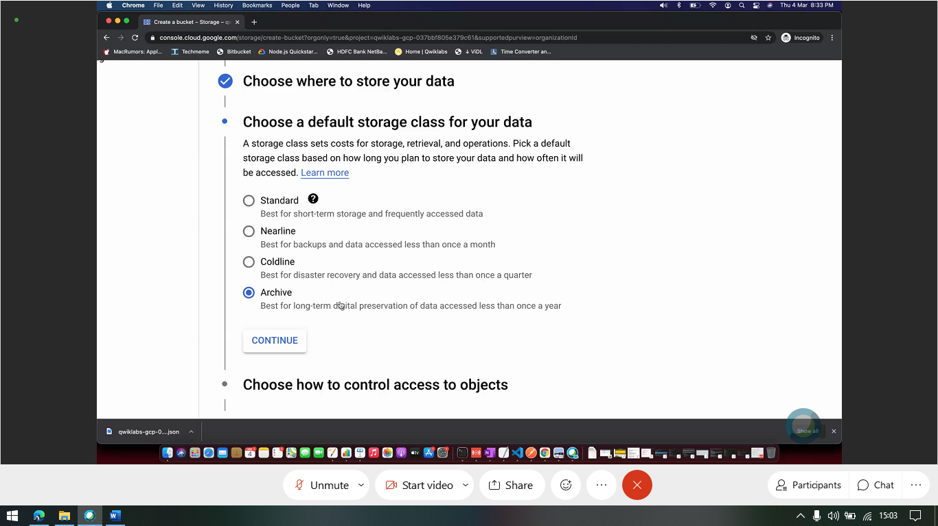

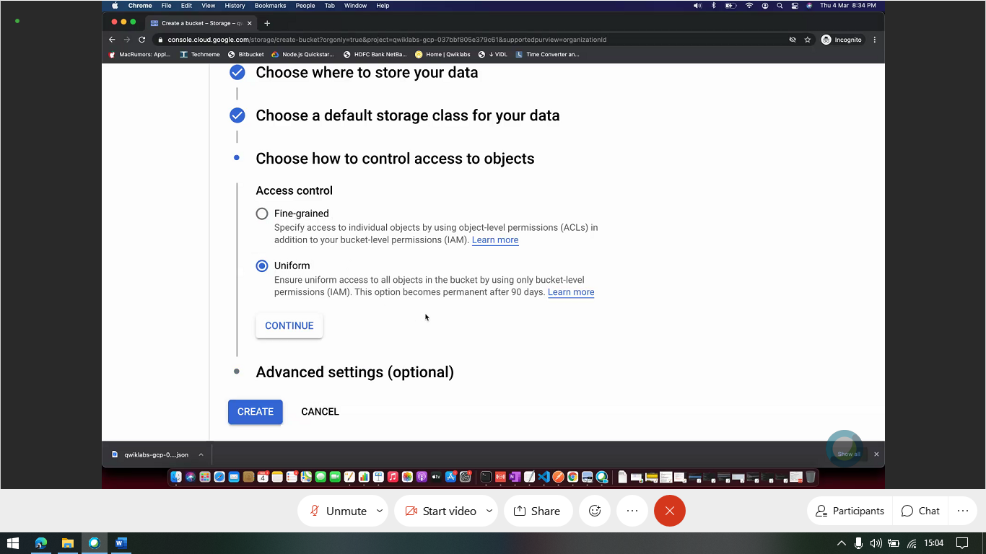

Fine Grained – ACL

Uniform – IAM

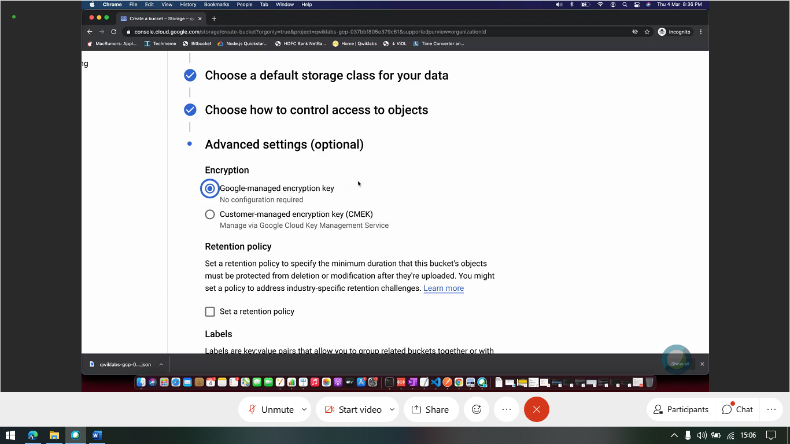

Encryption cant be turned off. Its always there – either google or user managed key.

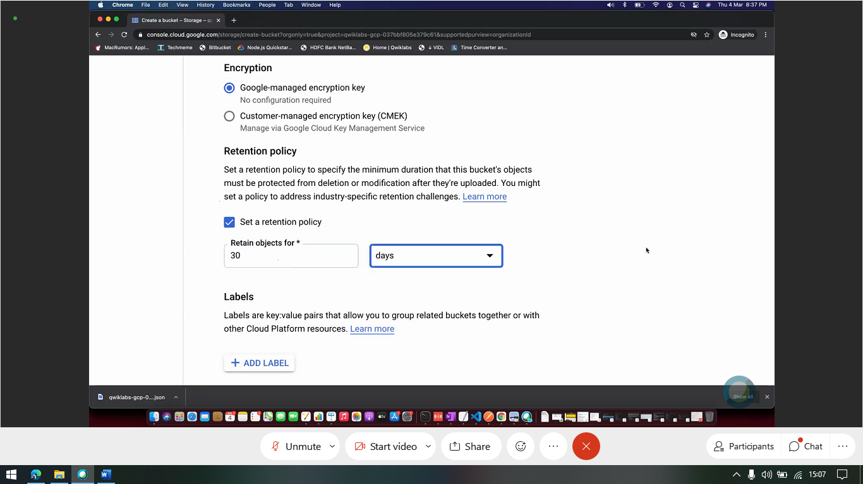

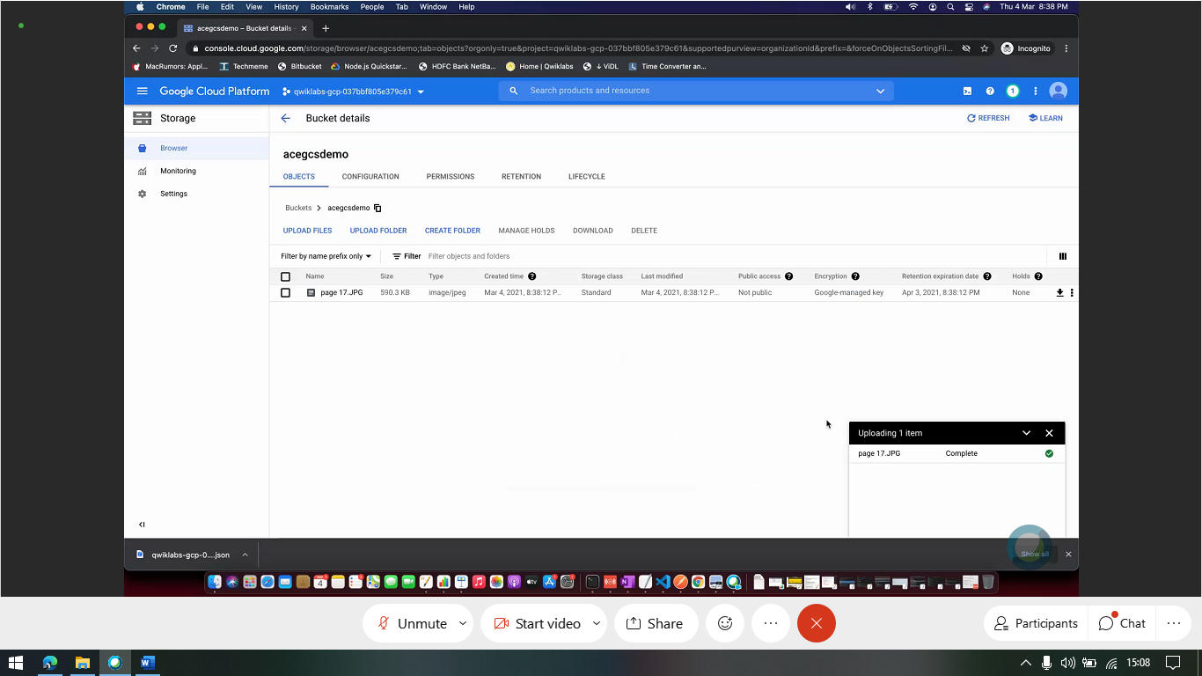

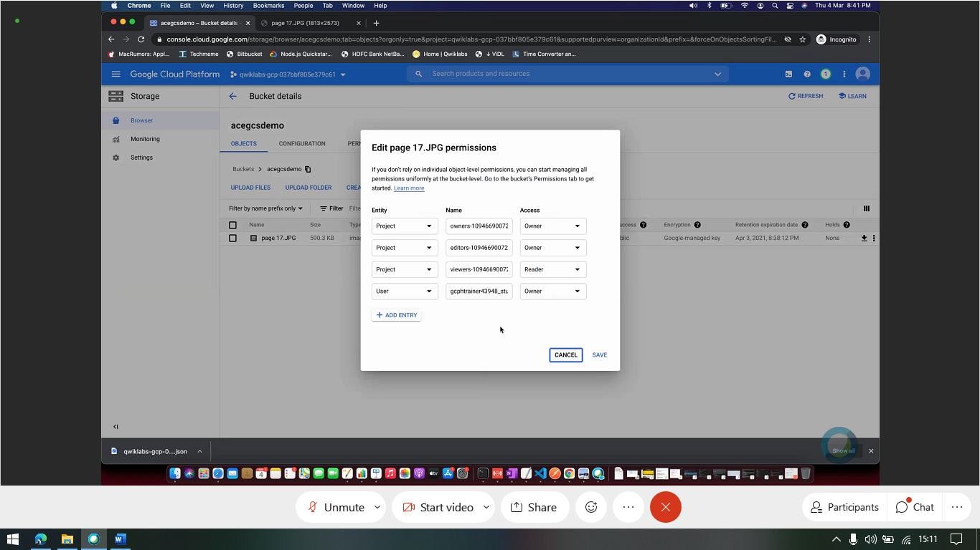

ACL above.

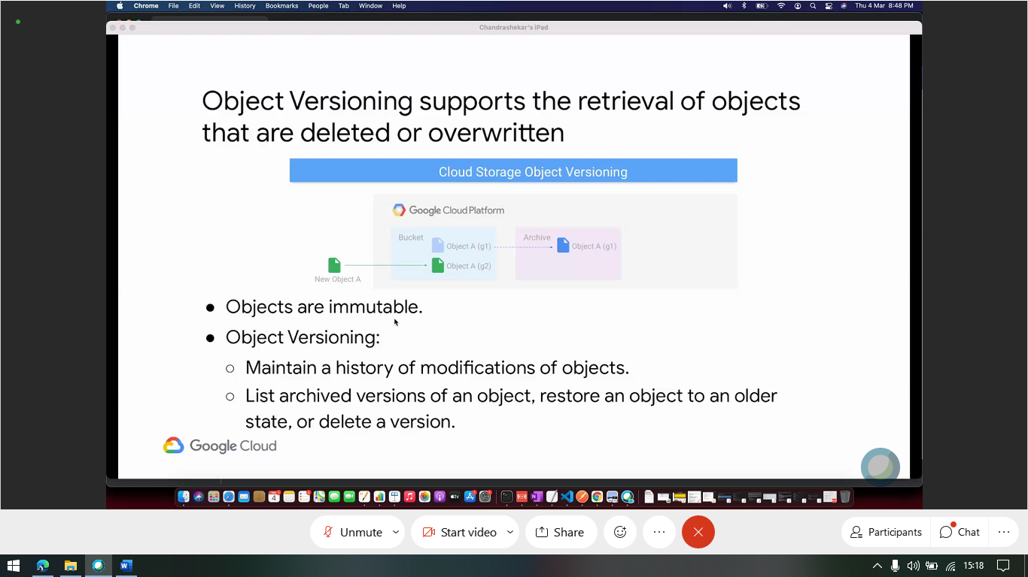

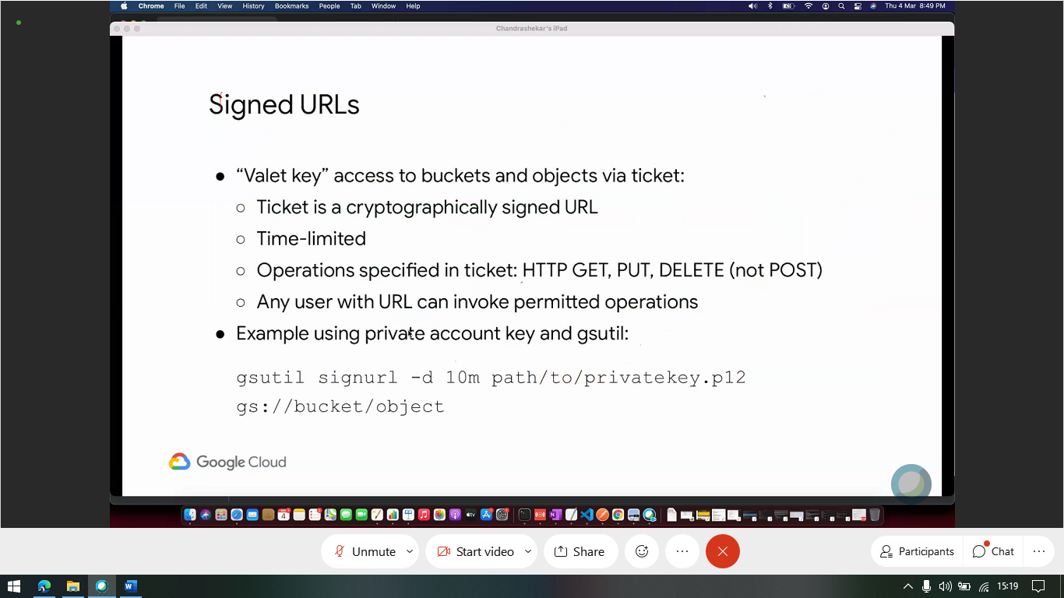

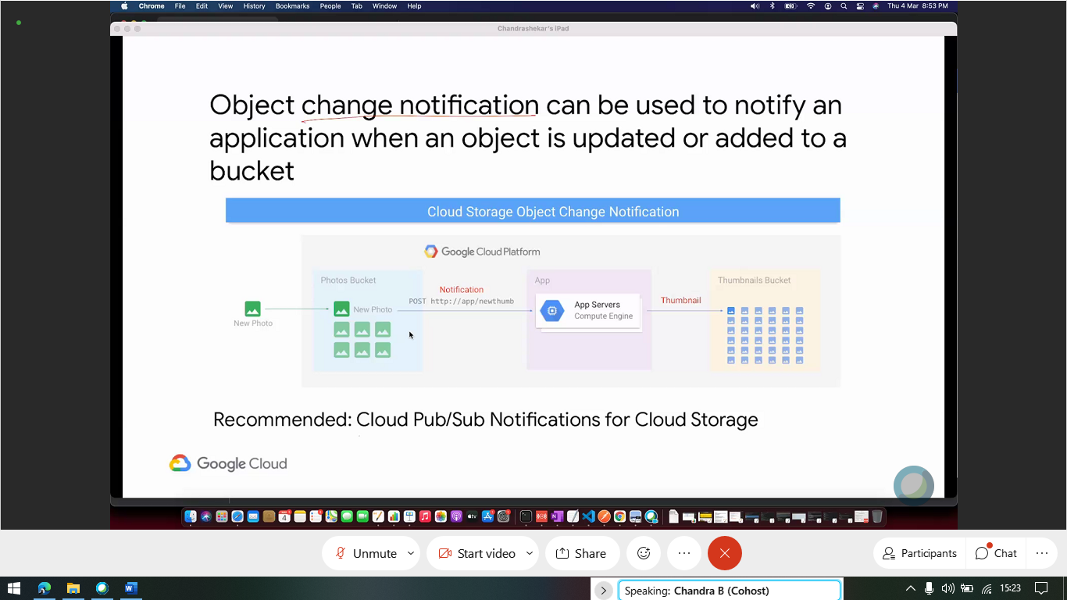

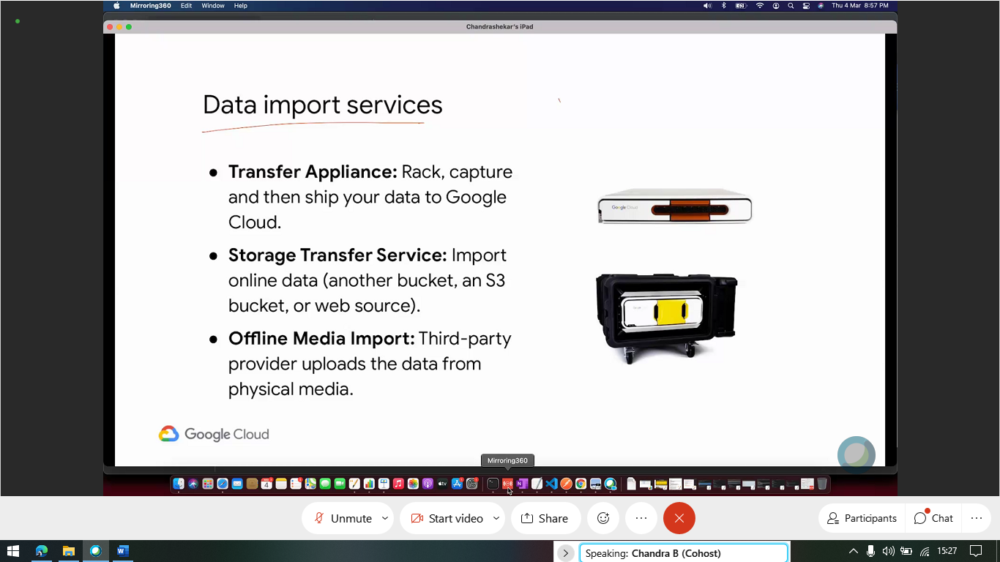

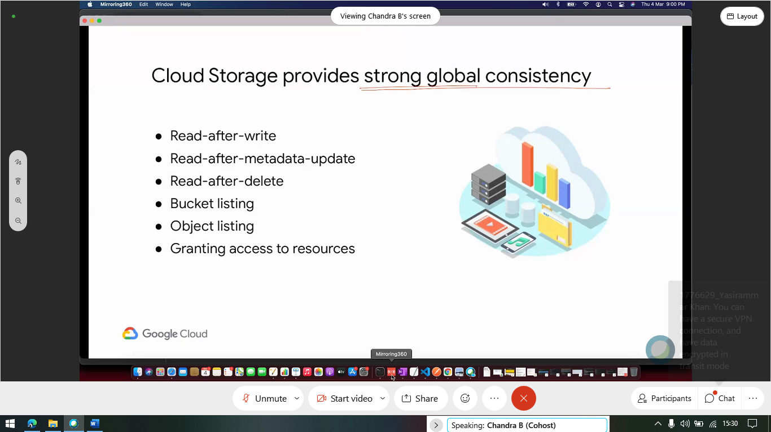

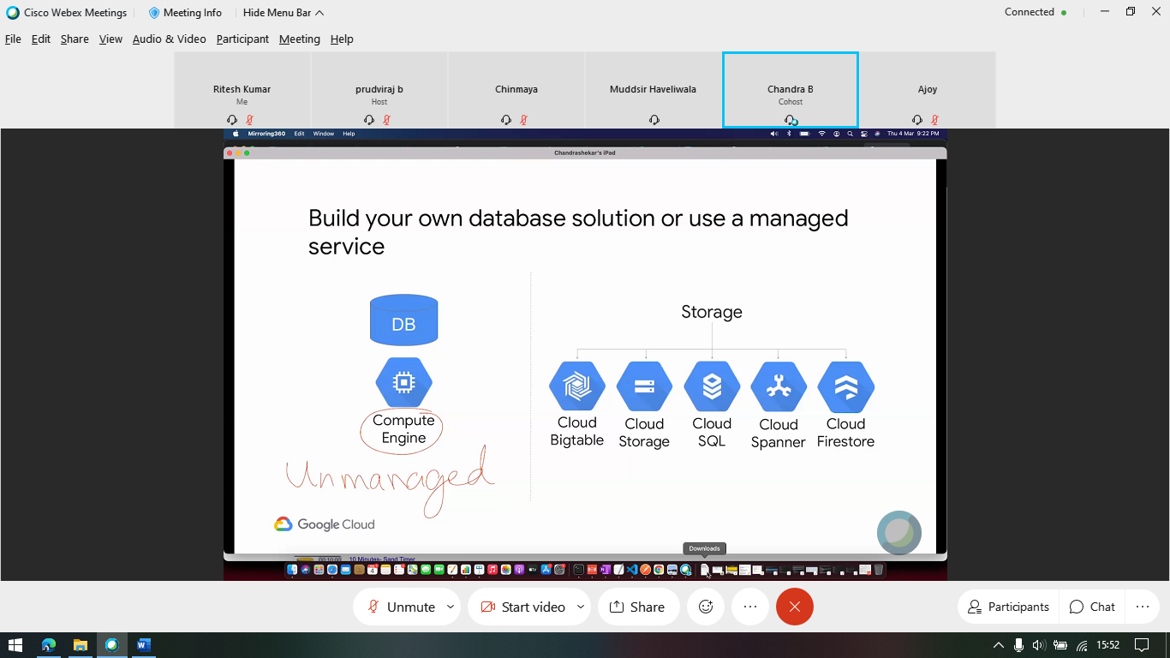

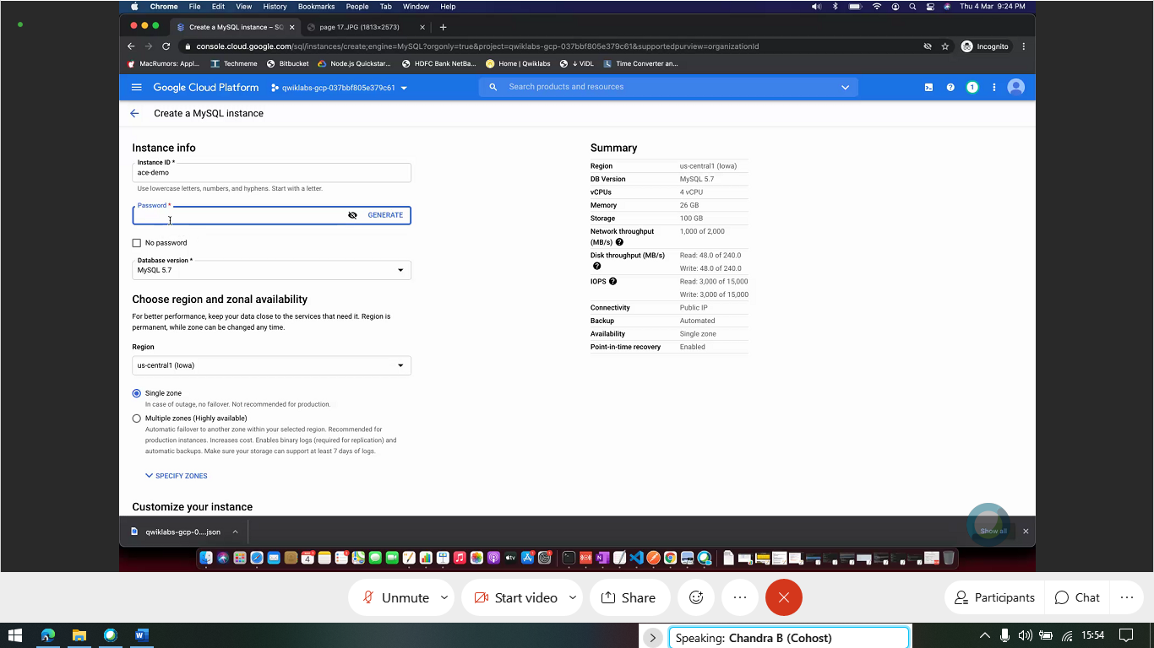

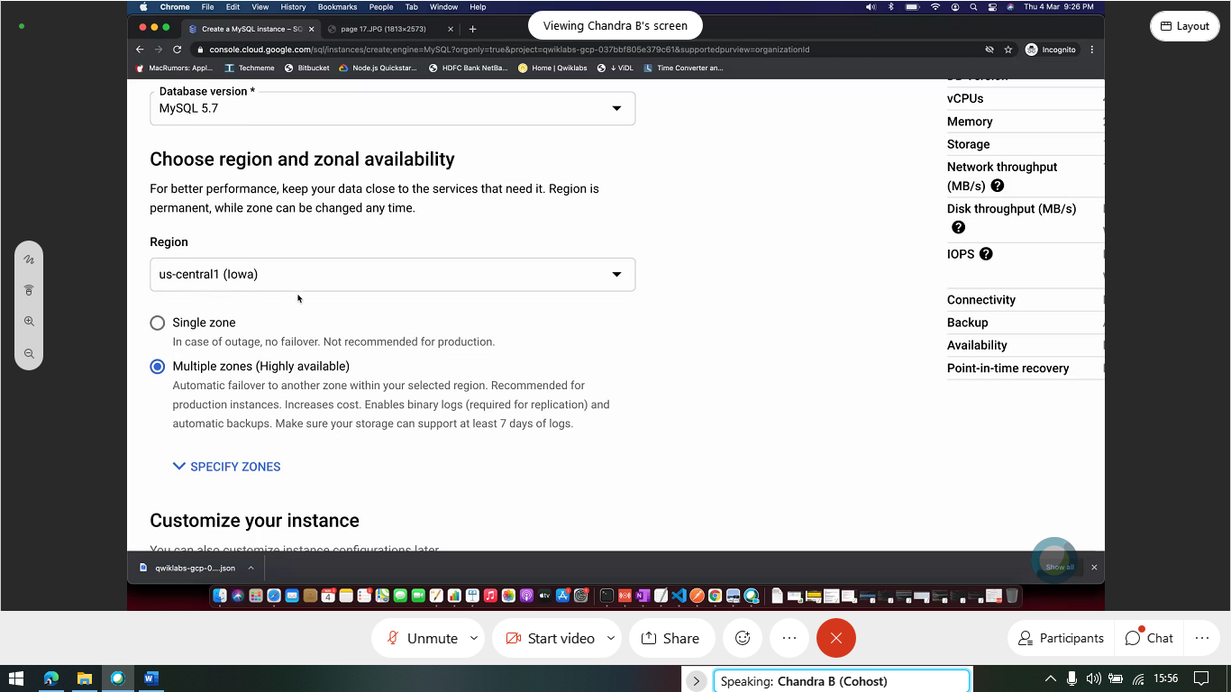

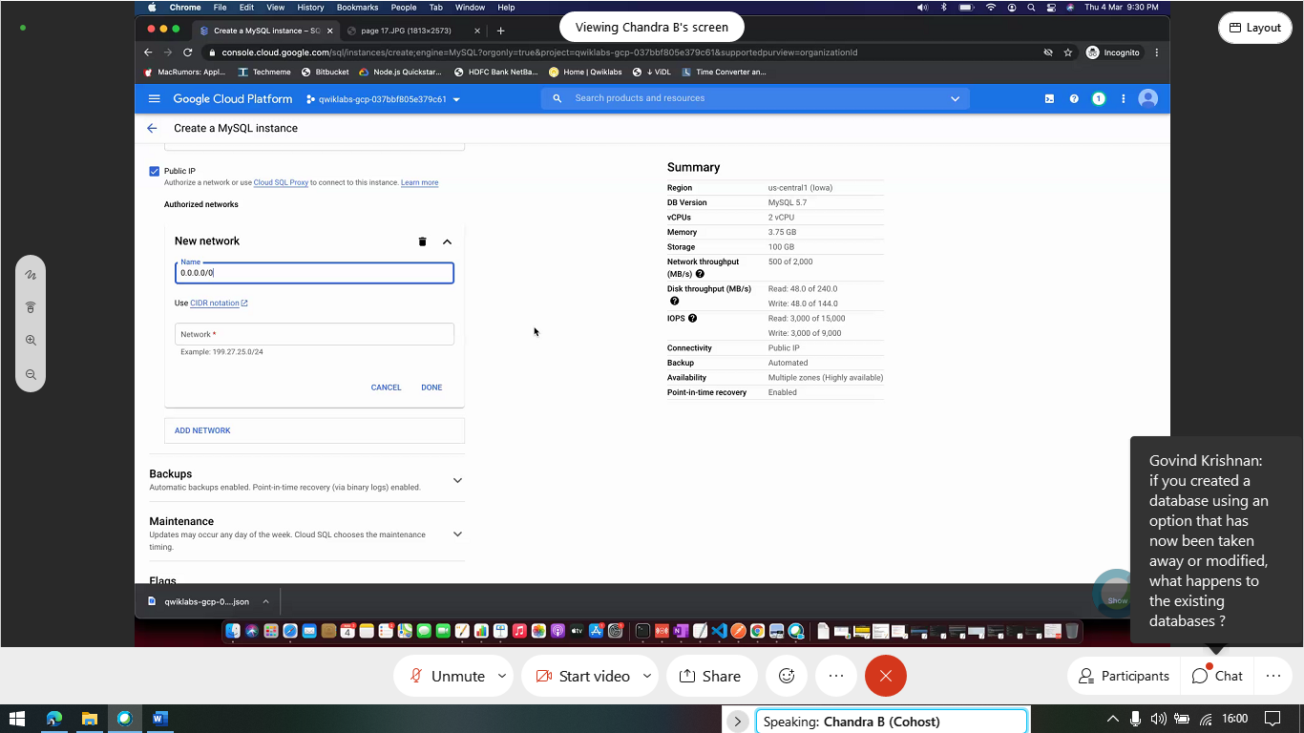

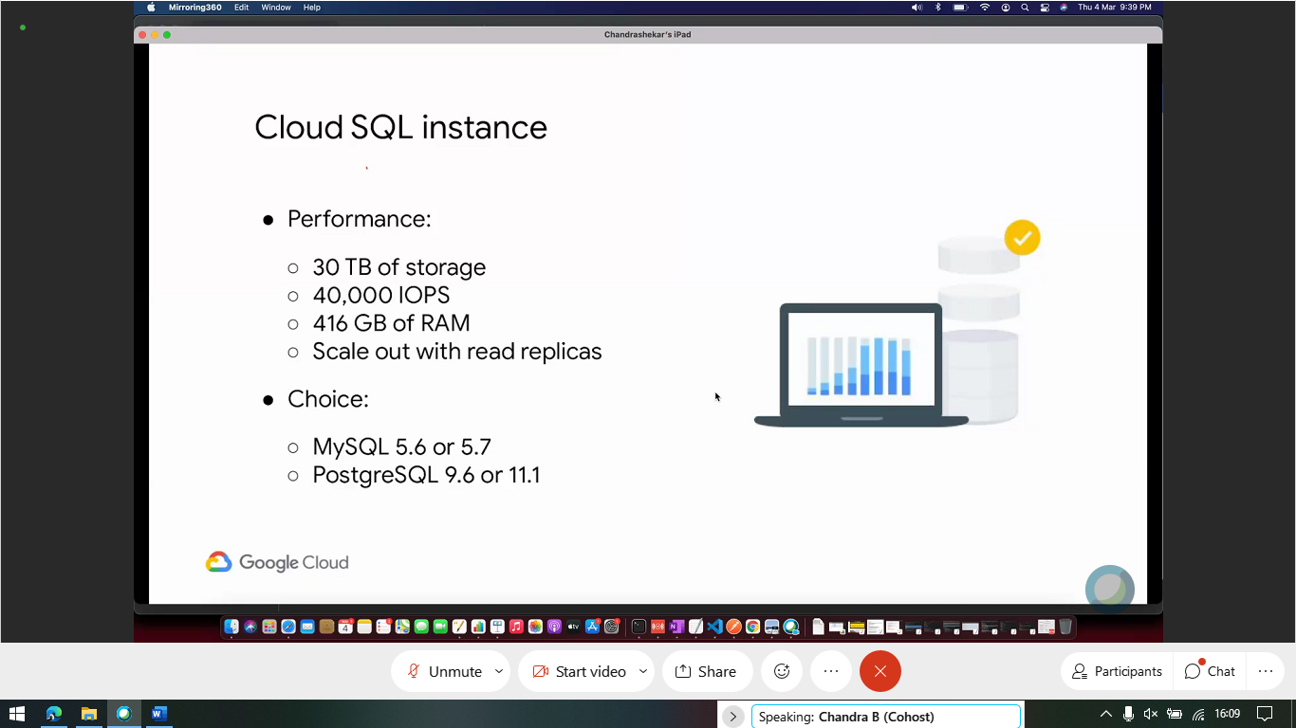

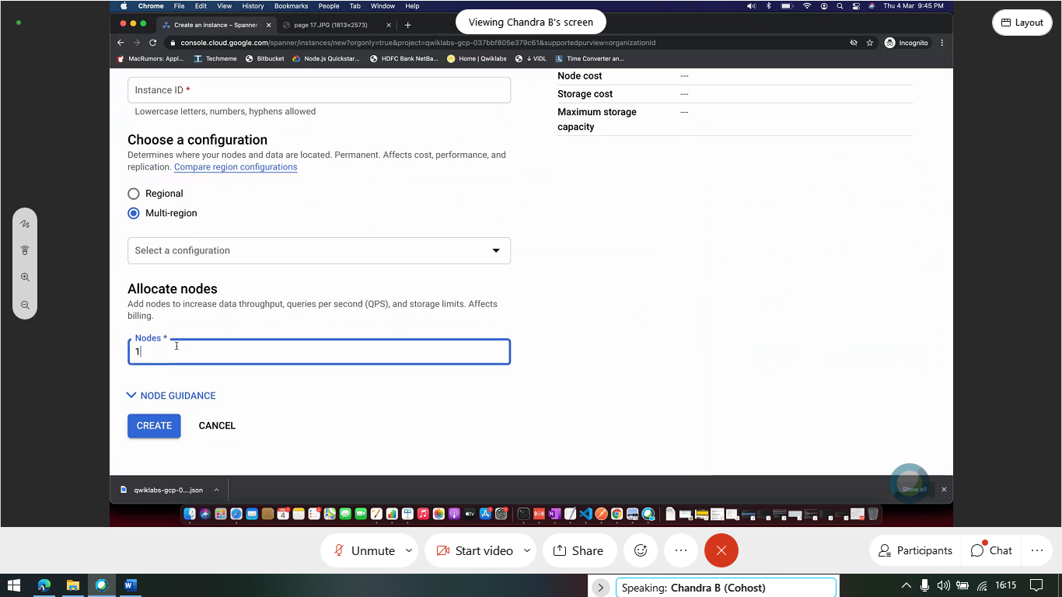

Choosing which vpn:

